Cell Signaling and Homeostasis Modeling
Ally S and Sangah P Period 4

KEY:
Teal Play-Do: Cell receptor
Orange Play-Do: Enzyme
Yellow Play-Do: G-Protein
Pink Play-Do: Signaling Molecule
Blue Play-Do: Phosphorus

RECEPTION:
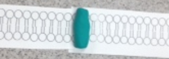
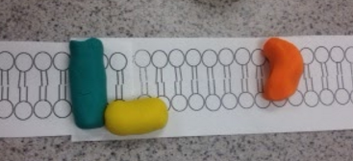
The model is showing how the G Protein moves and connects to the receptor.

TRANSDUCTION:
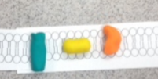
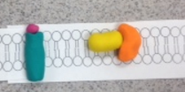
Then, the G Protein moves across the membrane and connects with the enzyme.

CELL SIGNALING:
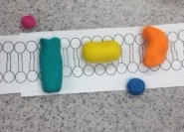
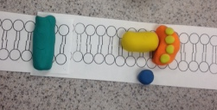
As the G Protein moves back across the membrane, the enzyme allows molecules to pass through. A phosphorus is the output molecule. Cell responses can include a hormone release into the body, and growth signals.

- What role does phosphorylation and dephosphorylation play in cell signaling?
Phosphorylation and dephosphorylation can affect an enzyme’s activity acting as a switch to turn it off or on in a regulated manner. Both mechanisms regulate protein activity. Phosphorylation activates each molecule. Dephosphorylation returns it to its inactive form.
- What role do secondary messengers, such as Ca+ 2 and cyclic AMP play in cell signaling?
Cyclic AMP: changing molecular activity in cytosol using Protein Kinase A (PKA); turning on new pattern of gene transcription
Ca + 2: muscle contraction; exocytosis; activation of T and B cells; sticking of cells to extracellular matrix; apoptosis
A role in activation of protein kinase / quickly transmits signals from a receptor to a target
- Why are they called secondary messengers?
Secondary messengers are molecules that are used like a relay team by sending messages that are received at the receptors on the cell membrane to target the inside of the cell.
- What does cell signaling have to do with homeostasis of cells?
Cells communicate with each other (by cell signaling) to tell one another when homeostasis is not being met. Communicating with each other that there’s a problem to be fixed, cells can signal what area/what needs to be done to regain the balance of homeostasis in the cells.
- How does what you learned about hormones relate to cell signaling?
Hormones are carried through the circulatory system, and then carried onto nearby target cells in the body. Hormones can be sent to the cells’ receptor to signal another change in the body. These hormones can regulate different body function.

- How else, besides cell signaling, do cells do to maintain homeostasis? Be specific
The definition of homeostasis can be summarized as the “same state”. Plant health depends of the availability of water, air, light, and the nutrients required for the plant to grow. Plant cells have rigid cell walls that also regulate plant growth and health. The vacuole is one of the major components of a plant cells that maintain homeostasis in the cell.

- Organisms respond to changes in their environment through behavior and physiological mechanisms of an organism(s).
A specific example of a physiological mechanisms would be a change in temperature. A bird gets a message from their brain when it gets cold. Then, the birds will fly South so they stay warm and they won’t freeze. It is a response from a signal they are receiving. A behavior mechanism would be if an zebra sees a tiger, it would run and try to escape. The zebra would receive a message saying that there is danger present and try to escape the danger. These mechanisms can help save the lives of the animals the messages are being sent to. This is just like the receptor proteins that are used the triggers a response in the body, like releasing a hormone. In the zebra, adrenaline could be released into the body like an extra protection layer.

