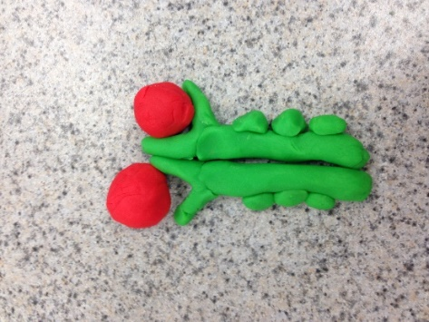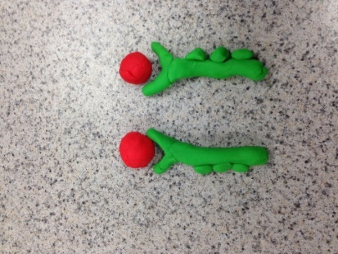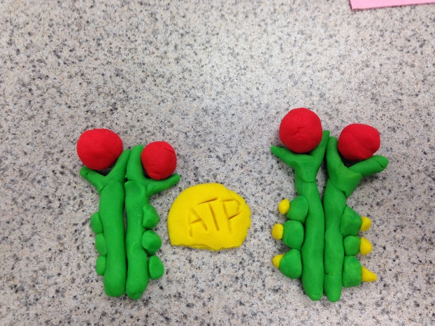

The tyrosine-kinase region becomes activated after the forming of the dimer. Then it goes under ATP causing phosphates to attach to the tyrosines in the tail. Causing it to be fully activated and becoming a phosphorylated dimer.

**Blair & Doha**

There are two separated receptor tyrosine kinases proteins. Each of the receptors have their own binding sites which are on the outside of the cell. The tail is inside the membrane is made up by many tyrosines. When the signaling molecule attach to the binding sites, they cause the two receptors to join together.

**Reception**

**Transduction**

**Cell Response**

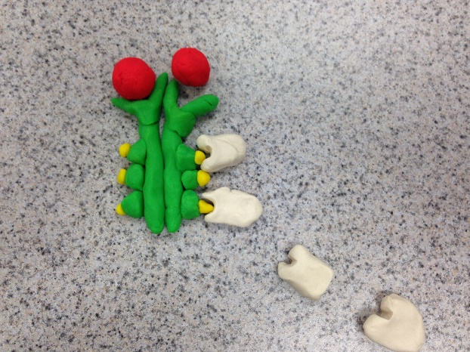

**Relay Proteins**

**ATP/ phosphates**

**Tyrosines/ dimer**

**Signaling molecule**

**Key**

Inactive relay proteins connect to the fully active receptor proteins. Each activated protein triggers a pathway causing cellular response.

1. They modify the function of the proteins and regulate cellular processes.
2. They are located inside the cell as signaling molecules triggering changes.
3. They stop the receptor after the first messages is binded to the receptor
4. They allow communication between tissues, they send messages though out the cell causing equilibrium
5. It helps regulate the amount of RNA in a cell.
6. Cell membranes control what goes in and out of the cell. Diffusion allows a substance to reach equilibrium. Osmosis allows water to reach equilibrium
7. Behavioral mechanism in a dolphin is leaving the deep water to shallow water for the birth of the young. Physiological mechanism of a dolphin is that it excrete urea

**Questions**