Cell Signaling and Homeostasis Modeling- Receptor tyrosine kinases
Erica Bien, Heidi Bien, Hannah Gannon
- Reception
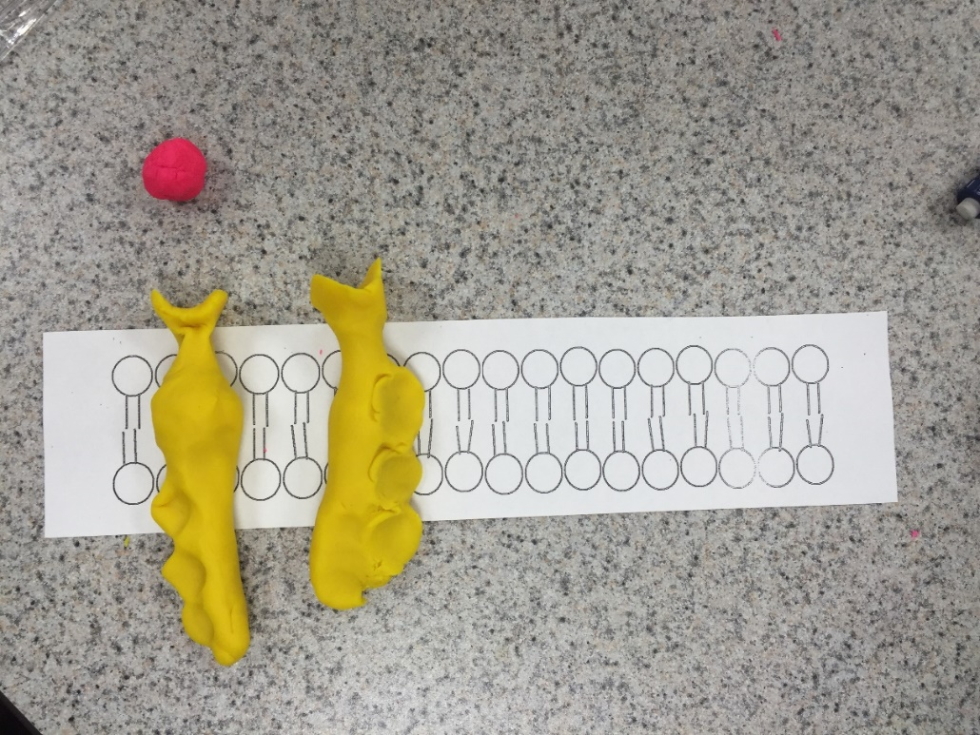
Signaling molecule

←Signal binding site

←Tyrosine
←Tyrosine
←Tyrosine

*Kinase: enzyme that catalyzes the transfer of phosphate groups
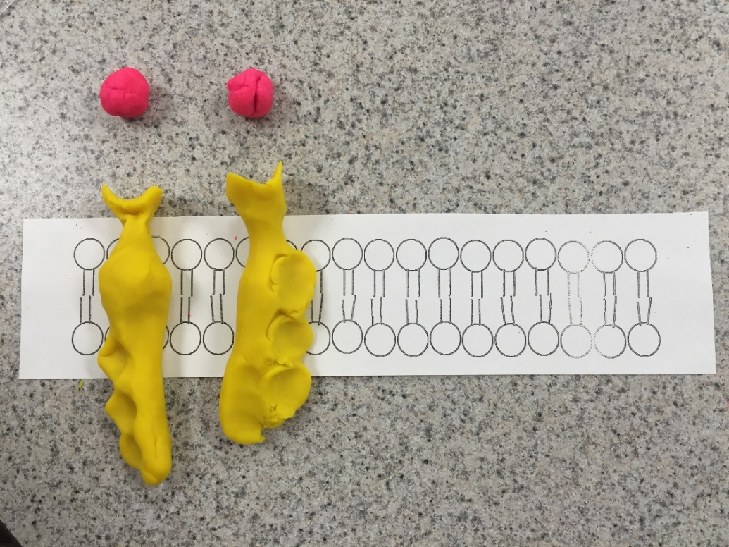

Receptor tyrosine kinase proteins

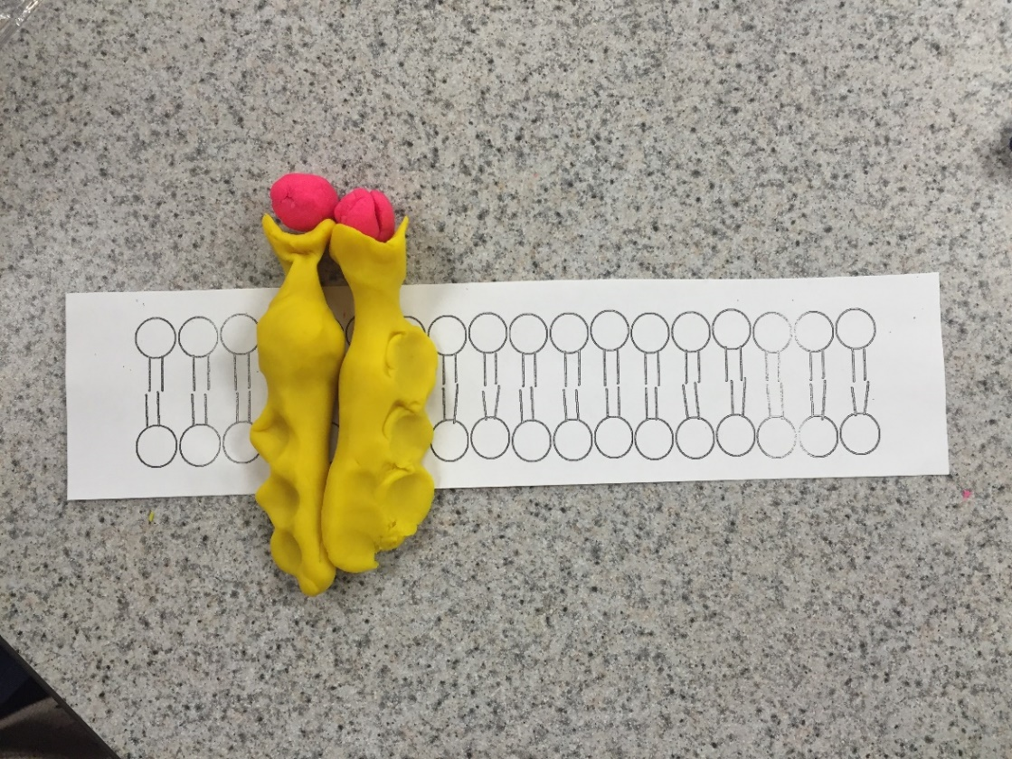

Dimer

- When signal molecules reach binding sites, receptors form a dimer (brings two receptors together)
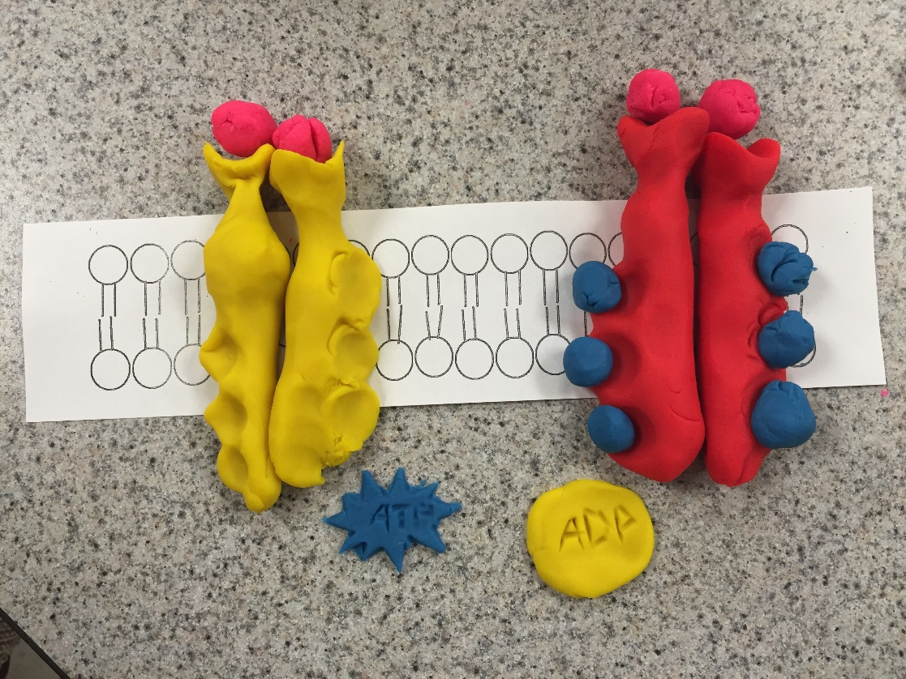

Unphosphorylated ↑ dimer (activated tyrosine regions)
↑ Phosphorylated dimer (fully activated tyrosine kinase)

- ATP donates a phosphate group and turns into ADP. The phosphate group attaches to a tyrosine. Repeats until all tyrosines are filled. The molecule is now phosphorylated.
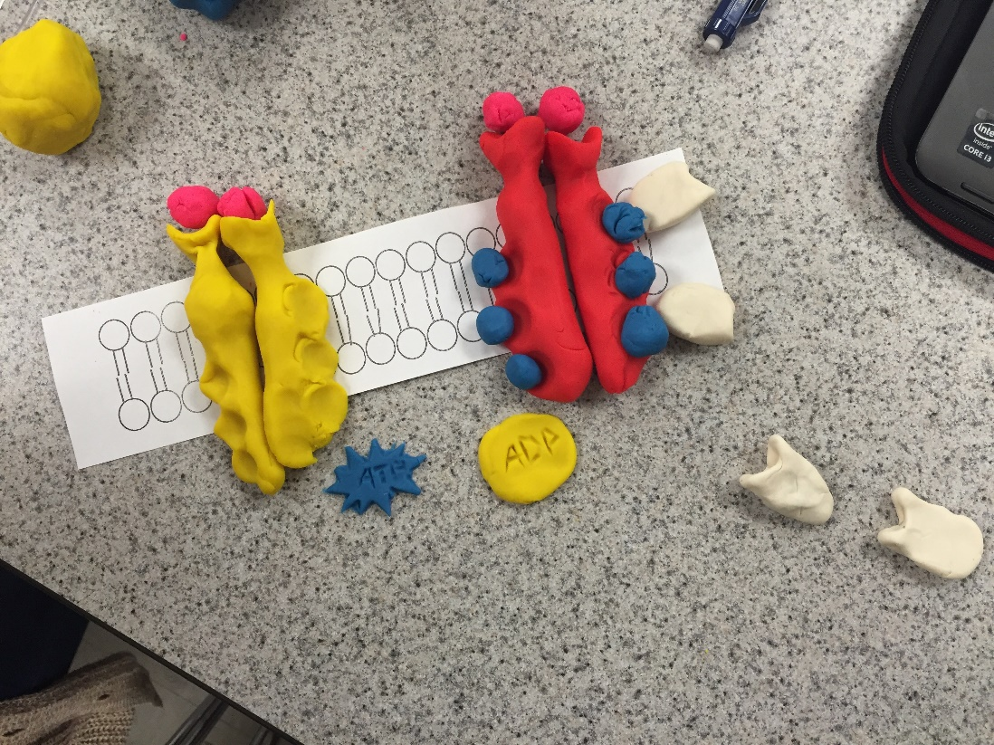

Inactive relay ↑ proteins

- Inactive relay proteins attach to a phosphorylated tyrosine, causing structural change in relay protein. Conformational change leads to signal transduction and a cellular response. Can have many cellular responses depending on how many tyrosines it has.
Questions
- Phosphorylation plays critical roles in the regulation of many cellular processes including cell cycle, growth, apoptosis, and signal transduction pathways. Phosphorylation transfers a phosphate group from ATP to the target protein. A protein can be activated or inactivated by phosphorylation. Dephosphorylation is the reverse reaction of phosphorylation.
- Secondary messengers relay signals received at receptors on the cell’s surface. They can also amplify the strength of the signal. Specifically, Ca2+ plays a critical role in the rapid responses of neurons and muscle cells. Cyclic AMP carries the epinephrine signal to appropriate molecules in the cell, causing an increase in heart rate and force of contraction of the heart.
- The term secondary messengers came from the discovery of these messenger substances in order to distinguish them from hormones and other molecules that function outside the cell as “first messengers” in the transmission of biological information.
- The ultimate goal of maintaining a constant internal environment is maintaining homeostasis which is essential for normal cell functions. Cells perform many biochemical reactions such as cell signaling to regulate homeostasis.
- The endocrine signaling uses chemicals called hormones to send messages throughout the body. Hormones are released from the cell into the bloodstream and can travel around the entire body. When a hormone reaches the receptor, the target cell responds to the signal.
- Vacuoles in plant cells play a large role in maintaining cell homeostasis by maintain the acidity and turgidity of the cell. The cell membrane regulates what passes in and out of the cell.
- An example of behavior mechanism is how male peacocks fan their feather to attract a mate. When a male attempts to attract a female, he spreads out his tail feather to display his colors and eyespots fully for her to see. The female observes the male and chooses whether or not he is a suitable mate for her. An example of a physiological mechanism is shivering from the cold. The hypothalamus controls thermoregulation and issues instructions to your muscles, organs, and nervous system when it senses your core internal temperature is too low or too high.

