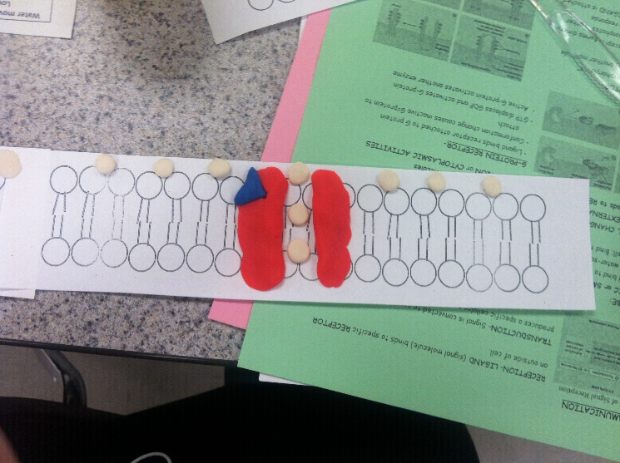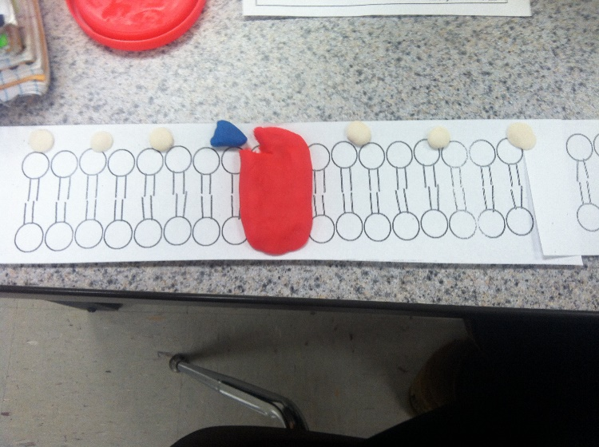Ligand-Gated Ion Channels

1. They turn protein enzymes on and off, which alters their function and activity.
2. Secondary messengers are signaling molecules released by the cell to trigger changes such as, migration and apoptosis.
3. Primary messengers cannot physically cross the phospholipid bilayer to make changes directly, and so the cell must use transduction methods to transduce the first messenger into the second messenger. This amplifies the strength of the original.
4. Cell signaling is part of a complex system of communication that regulates basic cellular activities and cell action. Homeostasis is the maintenance of steady states in the body, by physiological mechanisms. Cellular communication is essential to integrate and coordinate the systems of the body so they can participate in different functions. Different modes of cell communication differ in terms of length and speed.
5. In endocrine signaling, the signaling molecules (hormones) are secreted by specialized endocrine cells and carried through the circulation to act on target cells and distant body sites.
6. Osmosis, diffusion, and any kind of transport in which the water or ions travel through the membrane due to a lack of homeostasis.
7. Male red-capped manakins dance to attract a mate during mating season, and this could be competitive with other male manakins. (behavioral) When humans exercise excessively, their muscle cells expand rapidly to make the work of the muscles more efficient. (physiological)