Cell Signaling and Homeostasis Modeling
Sydney Hirrschoff & Jameson Meyer
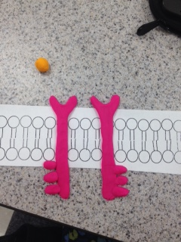
RECEPTION
The receptor tyrosine kinase proteins receive a signal molecule from the outside of the cell.

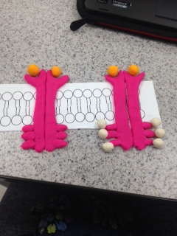
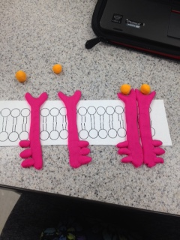
TRANSDUCTION
The receptor transmits the signal and receives ATP to prepare to respond to the signal.

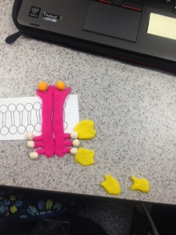
RESPONSE
The cell responds to the change made to its environment by signaling the activated relay proteins.
Specific cell responses that may occur: proliferation, differentiation, cell survival, metabolism

Analysis Questions
- Phosphorylation and the reverse reaction, dephosphorylation, occur thanks to the actions of 2 key enzymes. Protein kinases phosphorylate proteins by transferring a phosphate group from adenosine triphosphate (ATP) to their target protein. This process is balanced by the action of protein phosphatases, which can subsequently remove the phosphate group.
- Secondary messengers relay signals that the receptors on the cells surface receive and also send the signals to the molecules in the nucleus.
- They are called secondary messengers because they receive the signal from a primary effector and then send the signal to a secondary effector.
- The cell wants to maintain homeostasis, so it sends out signals if it needs to gain/lose anything to reach homeostasis.
- Hormones are chemical messengers secreted into blood or extracellular fluid by one cell that affects the functioning of other cells.
- Besides cell signaling, cells maintain homeostasis by having the cell membrane control which substances can enter and leave the cell.
- One example of a behavior mechanism is hibernation in the winter in response to the cold. One example of a physiological mechanism for an organism is night vision in response to the change in lighting.

