Takeaways from the AP Consultants 4Feb21 meeting.

CB used three guiding principles when creating and scheduling exams for 2021:
- Prioritizing the health of students and teachers,
- Need for full length tests due to requirements from colleges
- Advocating for an in-person proctored exam while recognizing the need for digital testing. CB understands the need for an in-person exam due to distractions that are present in student’s homes/alternative locations.

There are five main features of the CB administration in 2021
- There will be three testing windows: you can find them here.
  - In Administration 1, all exams are full-length paper and pencil, administered in school or another appropriate location necessary due to student numbers and social distancing requirements.
    - IPR reports will only be available for Administration 1 tests
    - Note that these times are local times for students outside the US.
    - Exams were removed from May 13 to avoid conflict with a religious holiday.
  - In Administration 2, half of the subjects’ exams are full-length paper and pencil, administered in school, and half are full-length digital exams, administered in school or taken at home.
    - Paper exams during this administration will be based on local times.
    - Digital exams are based on EDT (Eastern Daylight Time, UTC - 4)
  - In Administration 3, most subjects’ exams are full-length digital, administered in school or taken at home; nine subjects remain full-length paper and pencil, administered in school.
    - These exam start times are based on EDT (Eastern Daylight Time, UTC - 4)
Due to teacher request, math (Calc, Stats), Chemistry, and all three physics exams will have mostly in-person testing due to the heavy use of symbols on the test. Language exams won't have any digital exams due to the existence of Google Translate. Some exams will only be administered on paper one time.
You can mix and match between administration times - including between sections at a specific school
- Digital exams will be administered at home or at school. They must be authorized by the AP Coordinator but the decision is left up to the particular school.
- You may pick any testing window. Exams must be ordered by March 12, but which administration is chosen may be delayed and the decision may be made at a later date.
- There is no cancelation fee.
- There will be additional review sessions available on YouTube and AP Classroom.
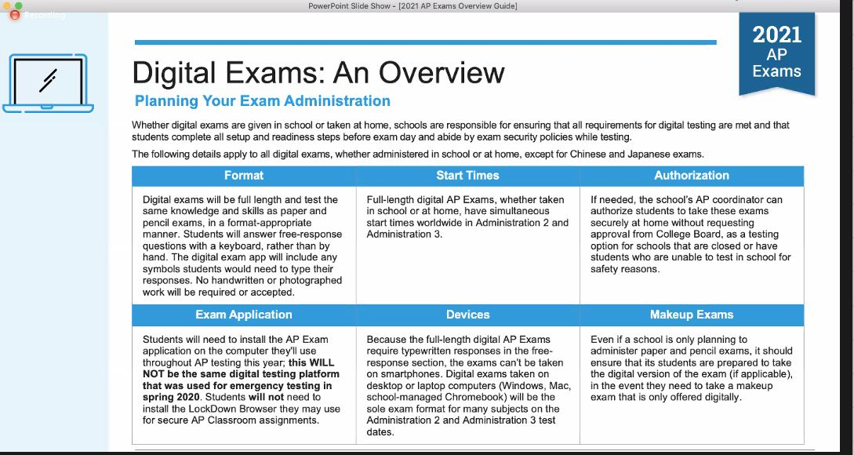

More notes about the digital exams:
- Schools should plan for a digital makeup exam if necessary
- The digital exam is full length. Students will take the exam using an app that is NOT AP Classroom and NOT the lockdown browser. It is an alternative app that students can install on their personal or school devices. IT IS NOT THE SAME PLATFORM AS 2020.
- Students will need to have access to a camera if taking a digital test and a photo ID.
- Digital exams will not allow students to click between questions or go back to previous questions. Only moving forward through the questions will be allowed.
- Students must use a personal laptop, computer, or school-issued chromebook. Smartphones will not be allowed as an exam taking device.
- No questions will be able to be answered using notes, google, textbooks, etc. Negating seachability will be a significant aspect of exam design.
- Digital exams will have a simultaneous start time globally. There is no overlap between paper and pencil times and digital exams.
- There will be different exams administered for each administration.
On March 2nd, a Digital Testing Guide with practice options will be available.

