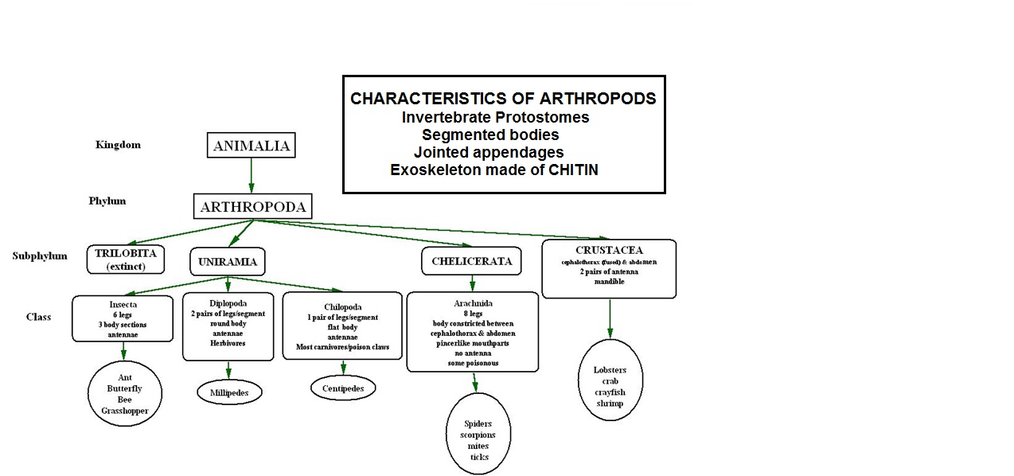
Diagram by Kelly Riedell/Brookings Biology

