NAME ________________________

CLASS: Aves “bird”
ORDER: COLUMBIFORMES (pigeons & doves)

INTEGUMENTARY/BODY

Modification for flight: FEATHERS provide lift; streamlined for decreased air resistance; insulation against heat loss; SKIN thin so weighs less

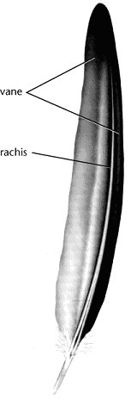
Birds are the only animals with FEATHERS. Feathers are modified scales made of KERATIN. Their function is to PROVIDE LIFT in flying and PRESERVE BODY HEAT. Feathers also provide coloration to attract a mate and hide from predators.

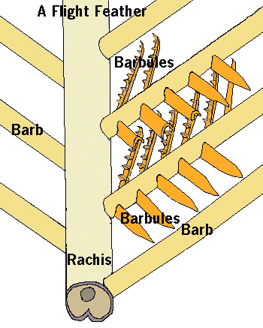
Examine your feather carefully: The structure of a feather combines MAXIMUM STRENGTH with MINIMUM WEIGHT.

Feathers grow from tiny pits
in the skin called FOLLICLES. Two VANES develop on opposite sides of a center shaft called
the RACHIS. Each vane has many branches called BARBS. The barbs are zipped together “like Velcro” by microscopic hooks called BARBULES.

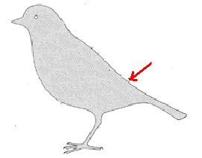
Birds straighten and care for their feathers by rubbing them with oil secreted by a PREEN GLAND at the base of their tail. Birds periodically MOLT or shed their feathers and grow new ones. Birds living in temperate climates usually replace their flight feathers (called a MAJOR MOLT) during late summer.

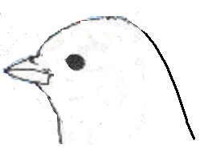

The fleshy bit of skin that lies over the beak
is called the CERE. Find the NICTITATING
MEMBRANE, the EAR OPENING, the BEAK,
and EXTERNAL NARES.

Birds see in COLOR and have keen vision which is important in taking off, landing, spotting landmarks,
hunting, and feeding. Having eyes on the sides of its head gives a bird a WIDE RANGE OF VISION.
This arrangement is most often seen in birds which may be prey of other animals so they can
watch for predators more easily.
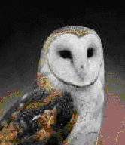
Birds with both eyes on the front of their head
have better BINOCULAR vision (DEPTH PERCEPTION) a necessity for hunting. This arrangement is most often seen in birds that are predators such as owls, hawks, and falcons.

Hearing is important to songbirds and in nocturnal birds
that must hunt for prey in the dark. Birds lack external
ears and have their TYMPANIC MEMBRANE inside.

NERVOUS
Modification for flight:
Large BRAIN for body size = “smarter”
Bigger CEREBRUM allows more complex behavior
(problem solving; learning; navigation; nesting; nest building; caring for young)
Bigger CEREBELLUM for muscle coordination during flight
Bigger OPTIC LOBES for better vision; color vision
Concentration of IRON in brain of migrating birds to detect magnetic fields
(acts like a compass)

SKELETAL
Modification for flight:
Bones = thin & HOLLOW; Many bones are FUSED for strength;
AIR SACS from lungs extend into some bones making them less dense
PYGOSTYLE (fused lower vertebrae) support tail for lift & braking during flight;
FURCULA (fused collarbones) stabilize shoulders during flight;
STERNUM (large breastbone) to attach flight muscles

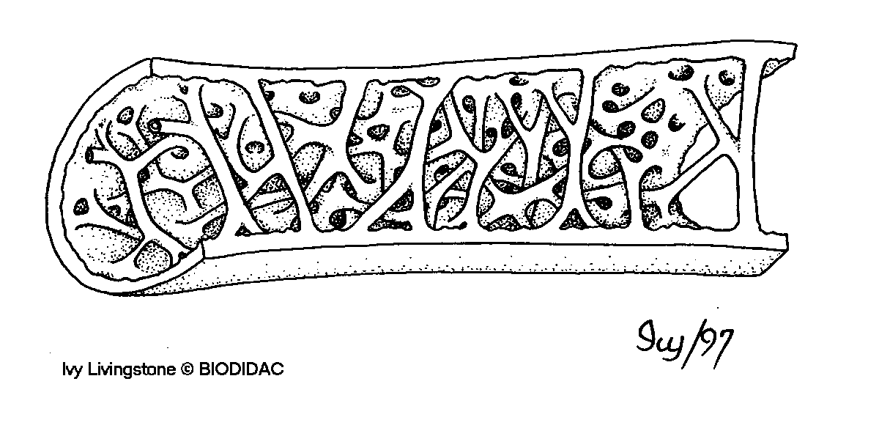
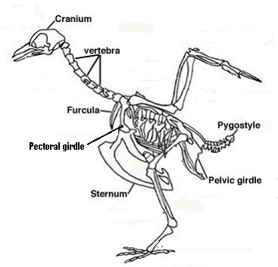

Bird bones are hollow to make them less dense than bones of non-flying animals.

Some bones (FURCULA, PYGOSYTLE) are fused
to make them stronger.

MUSCULAR
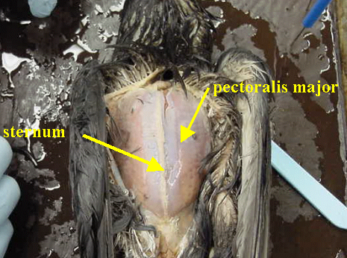
Modification for flight:
Large PECTORAL muscles attach to
sternum and power wings

DIGESTIVE
Modification for flight:
2 part stomach to speed food through system;
Crop for storage allows birds to eat when stomach is full so food is always moving
through digestive system;
Food fuels high metabolism (ENDOTHERMIC) so more energy for extended activity such as flying
Excess food stored as FAT for energy during long flights (migration)
Long SMALL INTESTINE to absorb lots of nutrients
Short LARGE INTESTINE to get rid of digestive waste faster
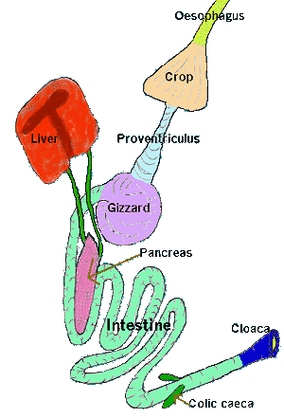
The large amount of energy needed to fly and regulate body heat (ENDOTHERMIC) is obtained by a quick and efficient digestive system.

Birds have NO TEETH to chew their food before it passes down the ESOPHAGUS into the CROP which stores food waiting to be digested. Birds have a TWO PART STOMACH to speed digestion. In the first chamber, the PROVENTRICULUS, acid and digestive enzymes begin breaking down the food. The second muscular portion called the GIZZARD contains small rocks the bird has swallowed which help in GRINDING the food.

Food is then passed into the very long SMALL INTESTINE where digestion is completed and nutrients are absorbed. The short LARGE INTESTINE absorbs water from and concentrates digestive waste.

The COLIC CAECA are found at the junction of the small and large intestine. These small pouches contain bacteria that AID IN DIGESTING PLANTS. Digestive waste is mixed with urine containing URIC ACID in the CLOACA before exiting through the VENT. The LIVER and PANCREAS still provide digestive enzymes

CIRCULATORY
Modification for flight:
Heart large for size of body
4 chamber heart (SEPTUM totally separates ventricle into 2)= most efficient/faster
2 loop system faster/gives extra push to blood going to body
RAPID HEART RATE moves oxygen/nutrients to body faster

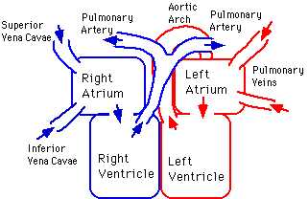

Birds have a CLOSED CIRCULATORY SYSTEM with 2 LOOPS (Pulmonary and Systemic) just like amphibians & reptiles. The difference in birds is the COMPLETE SEPARATION of the ventricle by a SEPTUM into a 4 CHAMBER HEART (2 atria and 2 ventricles). The SINUS VENOSUS and CONUS ARTERIOSUS have disappeared.
The LARGEST VEIN returning to the heart is the VENA CAVA. The largest arteries carrying blood away from the heart are the PULMONARY (to LUNGS) and the AORTA (to BODY).

Compared to reptiles and most other vertebrates, birds have a RAPID HEARTBEAT.
Like amphibians and reptiles the SPLEEN still makes, stores, and recycles red blood cells. Like reptiles and amphibians, bird red blood cells HAVE NUCLEI. Human RBC’s don’t.

RESPIRATORY
Modification for flight:
SUPER EFFICIENT respiratory system to meet HIGH OXYGEN DEMAND
AIR SACS allow oxygenated air in lungs during both INHALE and EXHALE
to provide more oxygen during high activity (flight)
AIR SACS from lungs extend into bones to decrease density
ALVEOLI in lungs increase surface area for more gas exchange
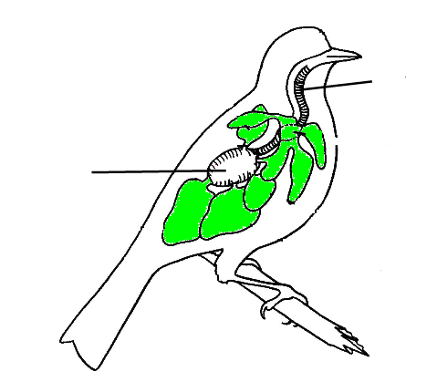
Birds have the MOST EFFICIENT respiratory system of any terrestrial vertebrate. Rapid metabolism requires an abundant supply of oxygen. Yet some birds migrate thousands of miles at high altitudes (up to 23,000 ft) where oxygen levels are very low.

Air enters through EXTERNAL NARES at the base of the beak and moves into the TRACHEA through the GLOTTIS opening in the back of the mouth cavity.

The air moves down the TRACHEA and branches into two BRONCHI (sing. BRONCHUS). From there SOME OF THE AIR ENTERS THE LUNGS. However, about 75% of the air bypasses the lungs and flows directly into the POSTERIOR AIR SACS that extend from the lungs and occupy a large portion of the bird’s chest and abdominal cavity (COELOM). These sacs also extend into some of the LONG BONES, so they function in RESPIRATION and also REDUCE THE DENSITY of the bird.

GAS EXCHANGE DOES NOT OCCUR IN THE AIR SACS. Their function is to STORE AIR. When the bird exhales the LOW OXYGEN AIR from its lungs moves into the ANTERIOR AIR SACS and the HIGH OXYGEN AIR from the posterior air sacs moves into the lungs. This way, the bird has high oxygen air in its lungs at all times… both on the INHALE and on the EXHALE! ALVEOLI in the lungs increase surface area for greater gas exchange.

The SYRINX (voice box), which produces sound, is a diamond shaped organ located where the trachea splits into the 2 bronchi. By regulating the flow of air birds can produce songs of great range and complexity. Male birds sing to warn away other males and to attract females.

EXCRETORY
Modification for flight:
No Urinary bladder = less weight
Nitrogen waste eliminated as URIC ACID (needs the least water to dilute);
Waste eliminated as made/ No urine storage
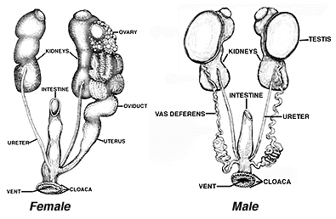

The avian excretory system is lightweight and efficient. The excretory organs in birds are the KIDNEYS. These elongated brownish organs are located along the back body wall under the reproductive organs on either side of the spinal cord. The kidneys REGULATE ION/WATER BALANCE of blood and tissues and REMOVE NITROGEN WASTE. Unlike other vertebrates, birds DO NOT STORE URINE… there is NO URINARY BLADDER! The kidneys filter nitrogen waste from the blood in the form of URIC ACID. This form is the LEAST TOXIC and REQUIRES THE LEAST AMOUNT OF WATER TO DILUTE. Concentrated uric acid waste moves through ducts called URETERS to the CLOACA, where it mixes with digestive waste and is eliminated through the VENT. Bird droppings are a mixture of feces and uric acid (the white colored material you see in “bird poop”).

ENDOCRINE
Modification for flight:
THYROID maintains HIGH METABOLISM (burns glucose) to provide energy for flight
PANCREAS (makes INSULIN & GLUCAGON) regulates blood sugar levels so fuel is
available for flight
ENDOTHERMIC metabolism provides energy for extended activity (flight)

REPRODUCTIVE
Modification for flight:
Females have OVARY and OVIDUCT on only 1 side (less weight)
Ovary enlarges during breeding season; shrinks in size rest of year
OVIPARITY = Lay eggs outside (less weight if egg NOT kept in body)

In males sperm is produced in the TESTES near the kidneys. Sperm passes through a small tube called VAS DEFERENS (plural: VASA DEFERENTIA) into the CLOACA.
During mating the male presses his cloaca against the female’s cloaca and releases sperm. Most females have a SINGLE OVARY ON THE LEFT SIDE of the body.
Remember seeing all the eggs in fish, frogs, and turtles… eggs are heavy! Having a single ovary lightens the load for flying! Birds lay AMNIOTIC EGGS. The OVARY produces the eggs and the albumen and shell are added in the OVIDUCT, just like in a turtle. Eggs pass through the CLOACA and VENT and are laid outside the body. CALCIUM CARBONATE makes the shell hard so birds can sit on the eggs to keep them warm.
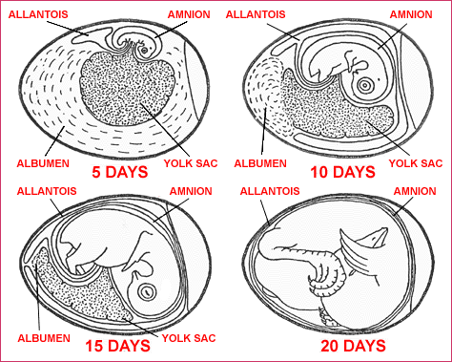
Most birds lay eggs in nests. Nests hold eggs, conceal young birds from predators, provide shelter from the weather, and sometimes attract a mate. One or both parents incubate,
(WARM) the eggs by sitting on them. A thickened, featherless patch of skin on the abdomen called a BROOD PATCH, allows skin to egg contact for more warmth.

In birds in the ORDER Columbiformes (pigeons & doves) the crop in both males and females secretes a nutritious milk-like fluid called CROP MILK to feed the young.

Birds that lay eggs in nests on or near the ground where they are more vulnerable to predators have PRECOCIAL YOUNG (babies that can walk, swim, and feed themselves shortly after birth). This allows the baby birds to be mobile sooner and increases chances for survival by better escaping predators. Birds that lay eggs in nests higher up in trees or places where predators can’t reach as easily have ALTRICIAL YOUNG (babies that are featherless, blind, and helpless which must be fed and cared for by the parents). This kind of baby would quickly be eaten if it was laid in a nest on the ground! Hatching this kind of babies up high protects them until they are more mature.

NAME ________________________

BIRD LAB

Latin meaning:
KINGDOM: _______________________
PHYLUM: ________________________
SUBPHYLUM: _____________________
CLASS: ______________________ ___________________
ORDER: ______________________

COMPARE THE CIRCULATORY SYSTEMS IN BIRDS and TURTLES

 | BIRD | TURTLE
# LOOPS ?
# of heart chambers ?
Has conus arteriosus & sinus venosus? YES NO
Number of  Atria ? Ventricles? | ___ atria  ___ ventricles | ____ atria  ____ ventricles
Septum
Partial ? Complete ?
Blood returning from lungs enters ?
Blood returning from body enters ?

Which part of the excretory system seen in fish, frogs, and turtles (and will see in mammals) is missing in birds to make them weigh less?

__________________________________

How is the OVARY and OVIDUCT different in a bird than in all of the vertebrates you have seen thus far?

________________________ ___________________________
Tell 2 ways the respiratory system in birds is different than in other animals with lungs?
1. Birds have ______________________ in addition to lungs.
2. Birds move oxygenated air into their lungs both when they __________________ & when they
__________________

The PYGOSTYLE, STERNUM, and FURCULA belong to the ______________________ system

Birds excrete their nitrogen waste as: AMMONIA UREA URIC ACID
How is the tympanic membrane in birds different from frogs and turtles?
BIRDS FROGS/TURTLES

___________________________ __________________________

Explain how the BROOD PATCH helps with REPRODUCTION:

__________________________________________________________

Tell 3 ways the BRAIN in a bird is modified to help with NAVIGATION:
(HINT: Look in the section for NERVOUS SYSTEM)

_________________________________________________________

_________________________________________________________

_________________________________________________________
Which part does it?

Stores and moistens food waiting to be digested __________________________

First chamber of stomach where acid &
digestive enzymes begin to break down food ____________________________

2nd part of the stomach that contains small
rocks to grind and mash the food ___________________________

Small gland near tail that makes oil used to keep
the bird’s feathers in good condition ____________________________

Small pouches which contain micro-organisms
that help to digest plant material ___________________________

Multipurpose exit cavity that receives digestive waste,
urine, and sperm/eggs before leaving the body _______________________

Voice box for singing, located near the junction of
the trachea and bronchi _______________________

Fleshy patch of skin above the beak in a bird ______________________

Dividing wall that separates the ventricle into two ______________________

Tubes that carry sperm from testes to cloaca ________________________

Tubes that carry urine from kidneys to cloaca ________________________

Tubes that carry eggs from ovary to cloaca and
add the albumen and shell to egg as it passes through ________________________

Gland that regulates heart rate and metabolism ________________________

Largest vein returning to heart _______________________

Largest artery leaving heart _______________________

Featherless patch of skin on the abdomen that
helps to keep eggs warm ________________________
Fingerlike extensions INSIDE the small intestine
that increase surface area to absorb more nutrients _____________________

Small sacs inside the lung that increase surface area
for more gas exchange _______________________

Large extensions off the lungs that store air
but don’t exchange gases _____________________________

Removes uric acid from blood and dilutes it
to make urine _____________________________

“Eardrum” _____________________________

3rd eyelid that acts as goggles _____________________________

Osmoregulation __________________________________

Make bile, store vitamins & glycogen, process toxins ________________________

Make trypsin, insulin, & glucagon ______________________________

Birds are/have:
INVERTEBRATES VERTEBRATES

PROTOSTOMES DEUTEROSTOMES

Ectothermic Endothermic

ACOELOMATES PSEUDOCOELOMATES EUCOELOMATES

HERMAPHRODITES SEPARATE SEXES

EXTERNAL FERTILIZATION INTERNAL FERTILIZATION

INDIRECT DEVELOPMENT DIRECT DEVELOPMENT

OPEN CIRCULATION CLOSED CIRCULATION

OVIPARITY OVOVIVIPARITY VIVIPARITY
DRAW DIRECTION ARROWS showing the flow of blood in a bird’s circulatory system.
USE RED (for HIGH OXYGEN BLOOD) and BLUE (for LOW OXYGEN BLOOD)

BODY LUNGS

RIGHT LEFT
ATRIUM ATRIUM

RIGHT LEFT
VENTRICLE VENTRICLE

