ZOOLOGY DISSECTION GUIDE
Created/compiled by Kelly Riedell
for students at
Brookings High School

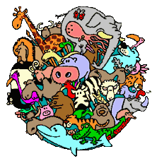

Includes excerpts from:
Modern Biology
by Holt, Rinehart, & Winston
2002 edition

Spring 2011

TABLE OF CONTENTS
PAGE
Earthworm Dissection 1
Clam Dissection 6
Starfish Dissection 10

Crayfish Dissection 14

Perch Dissection 18

Frog Dissection 24

Turtle Dissection 30

Pigeon Dissection 38

Rat Dissection 44

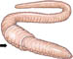
EARTHWORM DISSECTION
Kingdom: Animalia
Phylum: Annelida “little rings”
Class: Oligochaeta “few bristles”
(Lumbricus terrestris)
External Anatomy
Earthworms are SEGMENTED WORMS (Annelids)
Observe the segments or METAMERES along its body.
The advantages of SEGMENTATION include:
1) allowing different body sections to expand and contract independently
2). Duplication of body organs provides insurance against injury.
WHICH END IS UP? Examine your earthworm and determine the ANTERIOR and POSTERIOR ends by locating the CLITELLUM ring, the swelling (between segments 33-37) of the earthworm. This ring is closest to the ANTERIOR end and produces mucous for sperm exchange and cocoon formation during sexual reproduction. (See REPRODUCTIVE SYSTEM)
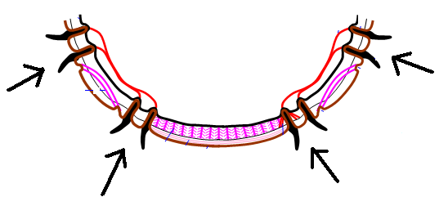
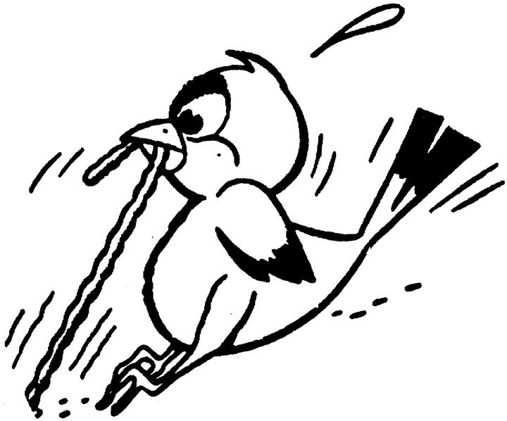
The MOUTH is located at the anterior end and is covered by the prostomium, a fleshy flap of skin that extends over the mouth opening. It prevents dirt from entering the worm’s mouth as it crawls through the soil and can sense light/dark and vibrations. The opening farthest from the clitellum is the ANUS.
Determine the DORSAL and VENTRAL surfaces by feeling for the SETAE, bristle-like structures located on the VENTRAL surface. 4 PAIRS of bristles on each segment except the first and last, provide the basis for the worm’s placement in the CLASS: OLIGOCHAETA (meaning “few bristles”)
Setae are used for traction and prevent the worm from
being pulled from the ground by a predator.
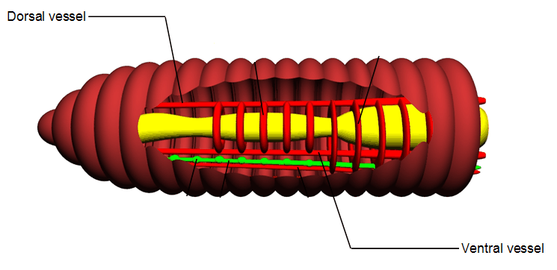

Locate the dark line that runs down the dorsal
side of the worm, this is the DORSAL BLOOD
VESSEL The VENTRAL BLOOD VESSEL can be
seen on the underside of the worm, though it is
usually not as dark.
CAMOUFLAGE
Differences in skin coloration are due in part to the rich blood supply to the earthworm’s skin;
important in gas exchange since earthworms “breathe” through their skin (See RESPIRATORY SYSTEM) and it also helps the worm to blend in with its environment. Darker coloration on top allows the worm to blend in with the soil and not be seen from above by a predator.
Rub your finger along the surface of the worm’s skin. The thin layer that peels off is the CUTICLE, a NON-CELLULAR layer that provides protection & prevents dehydration.

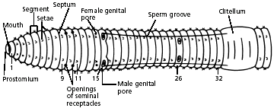
FIND THE EXTERNAL REPRODUCTIVE OPENINGS on the ventral surface.
OPENINGS TO OVIDUCTS (FEMALE GENITAL PORES)- segment 14
OPENINGS TO SEMINAL VESICLES (MALE GENITAL PORES) -segment 15
OPENINGS FOR SEMINAL RECEPTACLES (segments 9-11)
SPERM GROOVE runs from CLITELLUM to pores on segment 15.

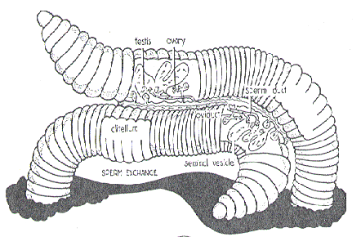
Earthworms are HERMAPHRODITES . . . each organism has BOTH MALE AND FEMALE sex organs, but they DON”T FERTILIZE THEMSELVES. They trade sperm with a partner.
Mucous produced by the CLITELLUM allows for sperm exchange
between partners Sperm are produced in the
testes and pass out through the male genital pores.
During mating, sperm from one worm travels along the
sperm grooves and is stored in the seminal receptacles
of another worm. Eggs are produced in the OVARIES and pass
out of the body through female genital pores.
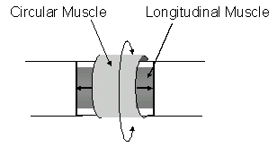 | MUSCULAR SYSTEM  Worm skin is very thin and contains two layers of muscle which work together to help the worm crawl. Contraction of the circular muscles elongates the animal and pushes the anterior end forward. Setae grip the ground as the longitudinal muscles contract, pulling the back end of the worm forward.
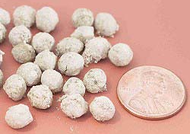
Fertilization of the eggs takes place later outside the body in a mucous cocoon produced by the clitellum. A mucous sheath containing nutritive material which slides forward, collecting eggs released from the FEMALE GENITAL PORES and the stored sperm of its mates released from the SEMINAL RECEPTACLES. The sheath finally slides off from the head of the worm. As it separates from the worm, its ends are sealed. It now becomes a cocoon which is left behind in the soil.
Cocoons contain CHITIN, a tough carbohydrate, which provides protection for the embryos growing inside. Earthworms produce between 4 -70 cocoons per year. Worms which live deep in the soil produce fewer cocoons, while the worms living on the upper layers produce more. Each cocoon may contain 2-20 embryos. Baby worms hatch in a few weeks.

Internal Anatomy
Turn the worm dorsal side up in your pan. Using a small scissors, make a shallow incision in the dorsal side of the clitellum at segment 33. Slice up the dorsal surface little by little working your way forward to segment 1.
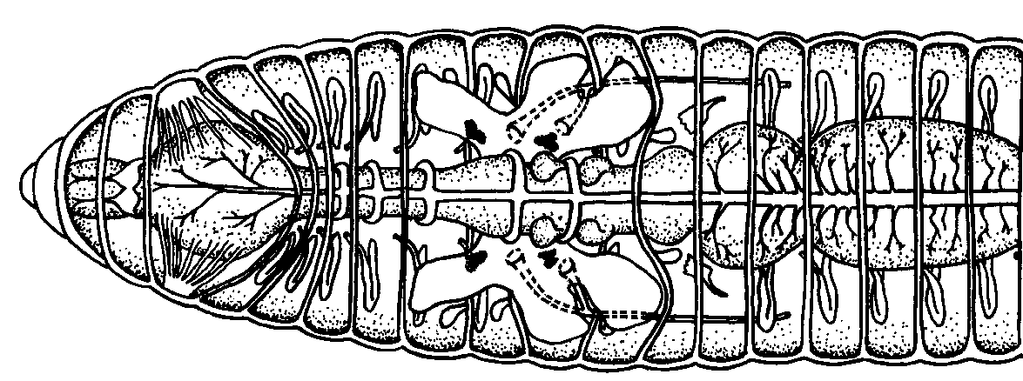
CAUTION: Scalpels and scissors are very sharp. Report any cuts to your teacher. Be careful to only cut through skin… not through organs below.
Gently open your incision and look inside to
see the dividers between the segments
called SEPTA (singular; SEPTUM).
BODY CAVITY (COELOM) /SKELETAL
Earthworms are COELOMATES. They have a “true” body cavity lined on BOTH SIDES by MESODERM. Find this COELOM (See-lum) space between the outside body wall and the internal organs in the middle. The earthworm (like other annelids) has a HYDROSTATIC SKELETON. Instead of a bony skeleton, fluid in the COELOM space provides support and protection for body organs and prevents the worm from being crushed.
RESPIRATORY SYSTEM:
Notice how THIN the skin is. Earthworms do not have RESPIRATORY ORGANS and exchange oxygen and carbon dioxide through their skin. Mucous glands keep the skin moist to allow gas exchange.
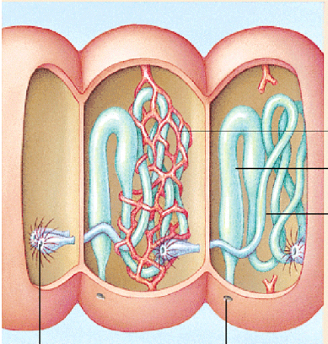
EXCRETORY SYSTEM:
Look also for tiny tiny tubules called NEPHRIDIA (singular; NEPHRIDIUM) A pair of these white thread-like structures is located along the dorsal body wall in each segment except the first and last. Their function is to COLLECT AND REMOVE NITROGEN WASTE. Worms excrete their nitrogen waste as UREA out through pores in the skin. Separate the septa along the body wall and pin open the skin.
REPRODUCTIVE SYSTEM
The SEMINAL VESICLES are the larger cream colored structures located toward the anterior of the worm. Sperm is produced by TESTES and stored here until it is passed to other worms during sex. Smaller SEMINAL RECEPTACLES can be seen underneath. These store sperm received from other worms during mating. Both of these reproductive structures connect to the openings you saw on the ventral surface of your worm.
Circulatory system (CLOSED)
The DORSAL BLOOD VESSEL appears as a dark brownish-red vessel running along the top of the INTESTINE. The pumping organs are the 5 AORTIC ARCHES which act as the “heart” to pump blood and can be found bridging over the ESOPHAGUS (just posterior to the PHARYNX). Circulatory fluids travel from the arches through the ventral blood vessel to capillary beds in the body. The fluids then collect in the dorsal blood vessel and reenter the aortic arches. The VENTRAL BLOOD VESSEL lies underneath the digestive system and can’t be seen at this time.
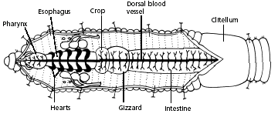
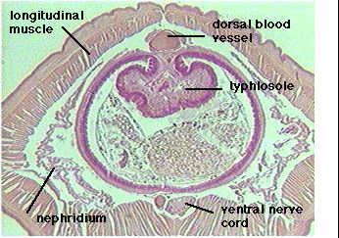
DIGESTIVE SYSTEM
Earthworms ingest soil & remove nutrients from the organic matter (leaf litter, animal waste)
Locate the digestive tract, which lies below the dorsal blood vessel. Refer to the diagram above to locate the following:
MOUTH - takes in food.
PHARYNX is a muscular structure located in segments 2 - 6 that pulls in food
ESOPHAGUS is a tube which carries food from the pharynx to the crop
CROP is a thin-walled sac that holds food until the gizzard is ready to receive it
GIZZARD is a thick-walled sac that is responsible for grinding up food
INTESTINE food is chemically digested and nutrients are absorbed
Indigestible material (waste) is eliminated through the ANUS.
The earthworm has several modifications to help it absorb the few nutrients found in the “not-very-nutritious” soil it eats.
1. TYPHLOSOLE (folded lining of the intestine) increases the surface area so more
nutrients can be absorbed.
2. REALLY, REALLY LONG intestine allows food to stay in contact with intestinal lining
longer so more nutrients can be absorbed.

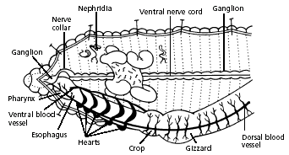
NERVOUS SYSTEM
A pair of CEREBRAL GANGLIA (small clusters of nerve cells in the head end above the pharynx) serves as the earthworm’s brain and connects to a NERVE CORD running the length of the worm’s body along the VENTRAL surface via a NERVE COLLAR
.

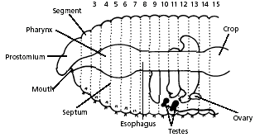
REPRODUCTIVE SYSTEM
Use the diagram below to locate and identify a pair of ovaries in segment 13. Look for two pairs of tiny testes in segments 10 and 11. To find these organs, you will again have to push aside some parts already dissected.

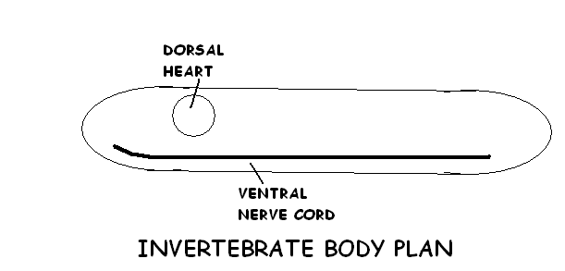
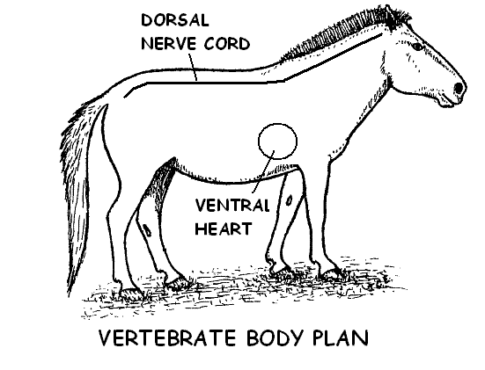
BODY DESIGN:
Notice the location of the worm’s heart (aortic arches) and its nerve cord.
Most invertebrates (at least those with a heart AND nerve cord) have a VENTRAL NERVE CORD and a DORSAL HEART. This design changes in VERTEBRATES. Vertebrates, like YOU, have a VENTRAL HEART and a DORSAL NERVE CORD.

EARTHWORM BENEFITS:
Earthworms play an important role in maintaining the fertility of soil: and as decomposers they play an important role in ecosystems.
1. Earthworms digest and decompose organic matter in soil (dead leaves, animal waste, etc)
2. Return nutrients to the soil for plants to use
3. Earthworm burrows allow oxygen to penetrate into the soil to reach roots.
3. Earthworms loosen the soil, making it easier for roots to grow and for water to seep in.
SURVIVING DRY CONDITIONS:
Earthworms must stay moist in order to gas exchange through their skin. During hot, dry conditions worms tunnel deeper into the soil, roll into a ball, and cover themselves with mucous. Their body systems slow down drastically. They go into a kind of suspended animation (ESTIVATION) just waiting for soil conditions to improve.

CLAM DISSECTION
Kingdom: Animalia
Phylum: Mollusca “soft body”
Class: Bivalvia “2 shells”

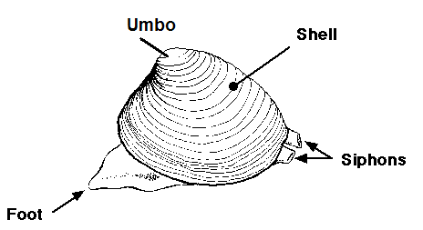
Mollusks are second only to Arthropods in numbers of living species and their estimated 85,000 species make up almost a quarter of all named marine organisms. Molluscs include more varied forms than any other phylum and are found on both marine and freshwater habitats. Clams ARE INVERTEBRATE PROTOSTOMES which surround their bodies with 2 shells (VALVES) connected by a hinge. Rings on the shell are “GROWTH RINGS”
and are an indication of the clam’s age.

WHICH WAY IS UP?
Locate the UMBO. This is the starting point for finding the
other directions. The umbo is on the DORSAL side.
The opening between the two clam VALVES (shells) is actually
on the VENTRAL side. The ANTERIOR is the end closest to
the umbo; the POSTERIOR is the end farthest away.
Clams do NOT HAVE CEPHALIZATION so
there is NOT really a head or tail end.
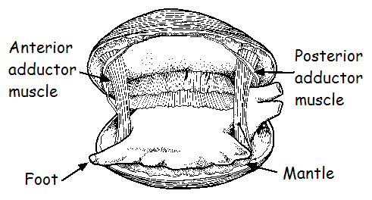
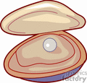
Use the figure at the left to locate the ANTERIOR and POSTERIOR ADDUCTOR MUSCLES. These control the opening and closing of the shells. Use your steak knife to cut through these two muscles so you can open the shell.
Examine the tiny TEETH along the inner dorsal edges of both valves near the umbo. Close the valves and see how the teeth interlock. These keep the shell from sliding side to side and coming open.

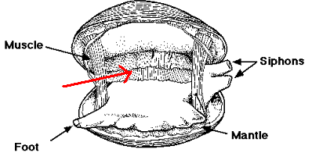
Run your finger along the outside and the inside of one of the shells. The MANTLE LAYER secretes the shell along with this shiny iridescent mother-of-pearl LINING to keep the rough scratchy shell from rubbing on its soft body. It is the same substance used to coat other “scratchy particles” like sand that get into its shell. This is how PEARLS are made. Identify the MANTLE layer next to the shell.

Next, find the SPACE that lies inside of the shells between
the MANTLE layers, but outside of the clam’s body. This is the
MANTLE CAVITY. Don’t confuse this with another space you know
about… the COELOM. This is NOT the COELOM! Remember the
COELOM is the space INSIDE the body wall that surrounds the
organs. The body organs are located inside the lump of tissue
in the middle. The MANTLE CAVITY is OUTSIDE of the clam’s body! THE
MANTLE CAVITY IS NOT THE COELOM! A number of body systems use the mantle cavity as an exit: the ANUS empties waste from the DIGESTIVE system into this space, the EXCRETORY system empties nitrogen waste into this space, and finally the REPRODUCTIVE system releases sperm or eggs into this space.
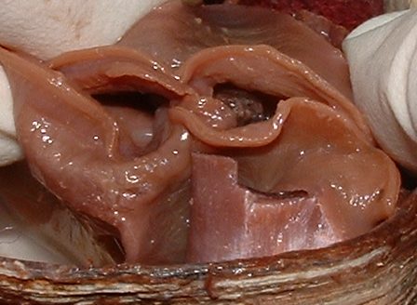
Place the mantle layers together as if the clam were closed.
Observe how the two sides come together to form 2 openings
at the posterior end of the clam. Water enters the more
ventral opening (INCURRENT SIPHON) and exits through the
the more dorsal opening (EXCURRENT SIPHON).
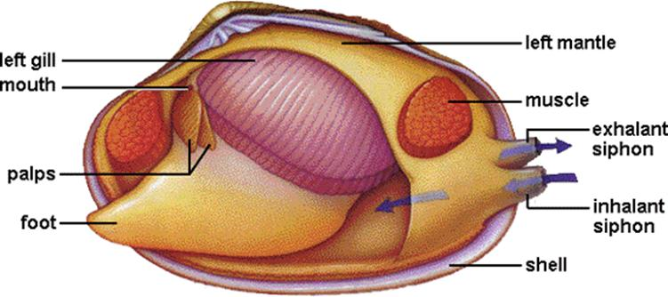

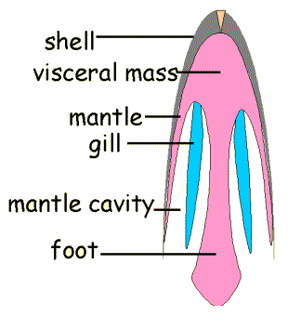
Observe the muscular FOOT of the clam, which is between the gills. Press on it with your finger. Note the shape. Can you see why clams were once classified in the PHYLUM Pelecypoda (“hachet foot”)? Locate the PALPS, fan-like structures that move food up from the gills and guide it into the clam’s MOUTH. Beneath the edge of the palps, you will find the MOUTH. Clams are FILTER FEEDERS. That means they strain food from the water rather than hunt and catch it.
The GILLS in a clam serve 2 purposes . . . GAS EXCHANGE (oxygen and CO₂ ) and TRAP FOOD. CILIA ON THE GILLS pull water into the MANTLE CAVITY through the INCURRENT siphon, move it over the gills, and back out through the EXCURRENT siphon. Water passing over the gills exchanges gases with the HEMOLYMPH (blood in an organism with open circulation) inside the clam and small food particles in the water are trapped in the mucous on the gills.
Remember from BIOLOGY that gases will move by DIFFUSION from a region of HIGHER concentration to a region of LOWER concentration.

So… oxygen (O₂) moves from the surrounding water into the clam and carbon dioxide (CO₂) moves from the clam out into the surrounding water automatically.
HOW DO GASES EXCHANGE?
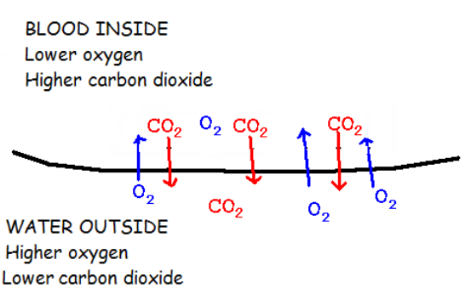

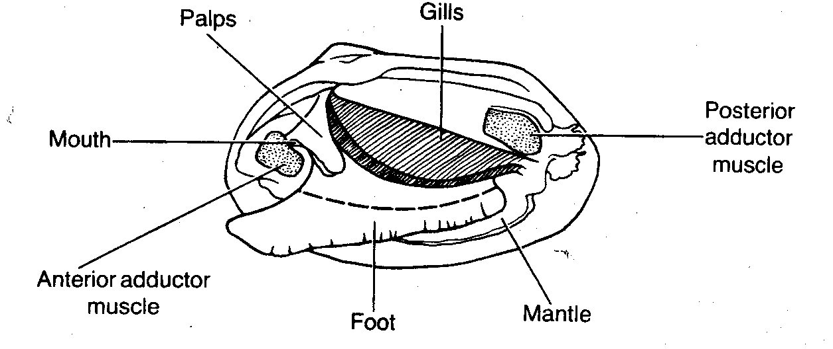

The clam’s body is divided into 2 main sections.
The HEAD-FOOT which contains the mouth and
some sensory organs and the large muscular
FOOT used for locomotion. Above the foot is
the VISCERAL MASS, which contains the heart,
excretory,digestive, and reproductive organs.

CIRCULATORY:
Clams have an OPEN circulatory system, meaning that the circulatory fluid (HEMOLYMPH) is not enclosed in vessels. It is collected from the gills, pumped through the heart, and released directly into spaces in the tissues. Open circulation is NOT AS EFFICIENT as a closed system because nutrients and oxygen are not pumped directly to organs. In addition, high oxygen and low oxygen blood can mix allowing fewer nutrients and oxygen to reach the cells.
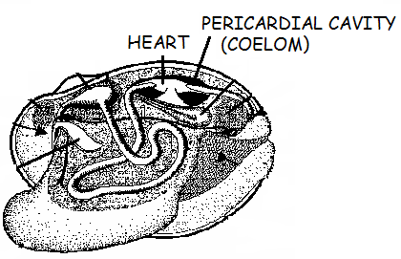
Look at the dorsal side of the clam’s body near the UMBO
for a transparent membrane-covered space that holds the
HEART. This space surrounding the heart is the
PERICARDIAL CAVITY. It is what remains of the COELOM
space. REMEMBER THE SPACE INSIDE THE SHELL WAS
NOT COELOM . . . THIS IS !

With your scissors, cut off the ventral portion of the foot, Cut into the visceral mass on each side and lift the top layer like a lid. You should now be able to see the internal organs.
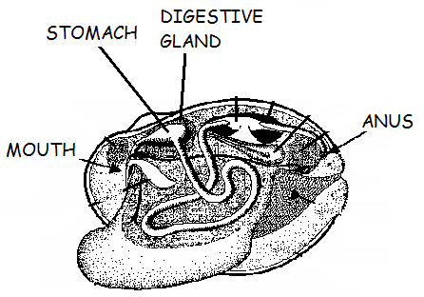

DIGESTIVE:
Look in the visceral mass for a greenish-colored area. This is the DIGESTIVE GLAND that surrounds the STOMACH. This gland makes digestive substance called BILE which helps the intestine break down FATS in food. Extending from the stomach is a long coiled INTESTINE. Food enters the stomach where digestion begins with the addition of bile and grinding of the food. Digestible particles move into the DIGESTIVE GLAND where digestion is finished and nutrients are absorbed. The intestine collects and removes digestive waste. The intestine passes underneath the HEART. The space around the heart (PERICARDIAL CAVITY) is what remains of the coelom space.
See if you can follow the digestive system toward the posterior end of the clam and find the ANUS. Feces empty into the mantle cavity just behind the POSTERIOR ADDUCTOR MUSCLE and near the EXCURRENT SIPHON. Since clams don’t move, placing the exit opening for digestive waste in this position allows digestive waste leaving the anus to be washed away by water exiting through the excurrent siphon.
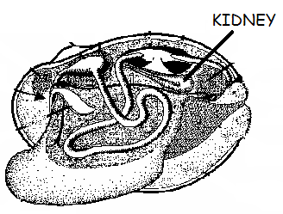
EXCRETORY:
The excretory organ in clams is the KIDNEY, just like you. This organ collects nitrogen waste produced by body cells from the breakdown of proteins and excretes it into the mantle cavity where it is removed by water exiting through the excurrent siphon. The kidney also maintains the balance of water and ions in the body (OSMOREGULATION).

REPRODUCTIVE:
Eggs are produced by OVARIES; sperm are produced by the TESTES. Reproductive organs are located near the pericardial cavity. Most species of clam have SEPARATE SEXES. That means there are both male and female clams. A clam has either testes or ovaries, not both. The general term GONADS can be used to refer to reproductive organs. Eggs or sperm are released into the mantle cavity.
Fertilization in clams depends on the species:
MARINE (ocean dwelling) clams – EXTERNAL FERTILIZATION
Eggs and sperm are released into the mantle cavity and leave by excurrent siphon
FRESHWATER clams- INTERNAL FERTILIZATION
Sperm enter mantle cavity through the incurrent siphon;
developing larva are discharged through the excurrent siphon.
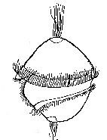
Aquatic mollusks have INDIRECT DEVELOPMENT. The fertilized egg becomes a TROCHOPHORE LARVA with cilia for locomotion. This larva is free swimming and eventually settles to the bottom and becomes an adult. As adults, clams are SESSILE . . . that means they stay in one place and don’t move around much. Some freshwater larvae spend time attached to the gills of a fish as they develop into adults,
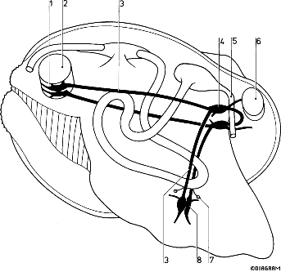
NERVOUS:
Clams have NO CEPHALIZATION. There is NO distinct head area. Instead of a pair of cerebral ganglia in the head connected to one ventral nerve cord like an earthworm, a clam’s nervous system consists o 3 PAIRS of GANGLIA throughout the body connected by TWO PAIRS of long NERVE CORDS. Nerve cells in the ganglia control the muscles involved in locomotion and feeding, and process sensory info about light, touch, and chemicals (food) in the water.

Clams follow the same body plan seen in earthworms and most other
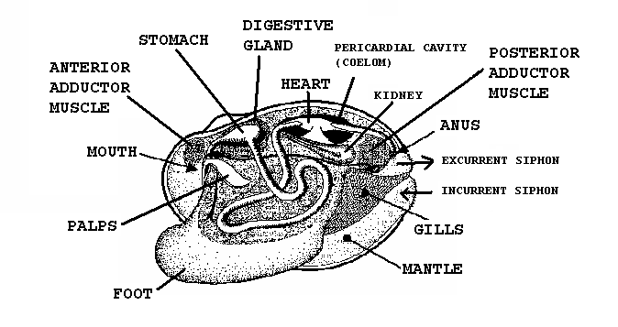
invertebrates with a DORSAL HEART and a VENTRAL NERVE CORD(S).

STARFISH DISSECTION
Kingdom: Animalia
PHYLUM: Echinodermata “spiny skin”
CLASS: Asteroidea “star-like”

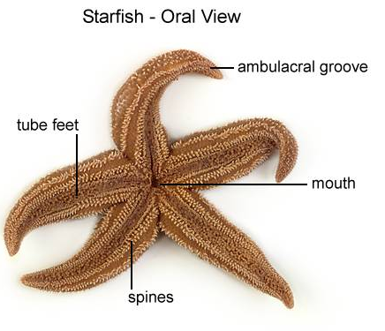
ECHINODERMS are spiny skinned invertebrates that include sea stars (starfish). sea urchins, sand dollars, and sea cucumbers. Starfish are MARINE (ocean dwelling) animals, not found in South Dakota. They feed on shellfish and can be a problem for the oyster industry.
Echinoderms are the ONLY INVERTEBRATE DEUTEROSTOMES!

Which way is up?
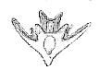
There is NO HEAD/BRAIN (NO CEPHALIZATION) in a starfish; therefore, no anterior or posterior. The surface where the mouth is located is the ORAL (VENTRAL) and the opposite surface is the ABORAL (DORSAL). This is the only RADIALLY SYMMETRICAL animal you will dissect this semester. Starfish typically have 5 arms, but there may be up to 24. Starfish with 5 arms (rays) are said to have PENTARADIAL symmetry.

Although adult sea stars have radial symmetry, they develop from winged
BIPINNARIA LARVA with BILATERAL symmetry.

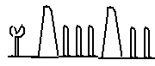
INTEGUMENT: The large SPINES on both the ORAL and
ABORAL surface of the skin give this organism its PHYLUM
name ECHINODERMATA (spiny skin). They are for protection.
Think how much fun it would be to bite down onto one of these!

The spines connect below the skin to a network of calcium plates called OSSICLES that make up the ENDOSKELETON. The smaller white specks in between the SPINES are tiny jaw-like pinchers with claws on stalks called PEDICELLARIA (pl. PEDICELLARIAE). Because starfish “breathe” through their skin, keeping the surface free of algae and other small organisms is important. These pinchers keep the starfish’s surface clear and prevent “critters” from growing on it. In some species these can be venomous. Pedicellariae are found on BOTH THE ORAL AND ABORAL surfaces.

RESPIRATORY/EXCRETORY
Echinoderms have NO actual excretory or respiratory organs. GASES (oxygen and carbon dioxide) and NITROGEN WASTE are exchanged between the fluid in the coelom cavity and the water outside through soft, hollow, thin-walled tubes that project from the surface called SKIN GILLS and through the thin surfaces of the tube feet. These many surface extensions provide increased surface area for gas exchange and are found on BOTH the ORAL and ABORAL surfaces.

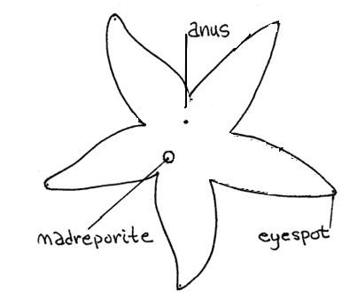
OTHER ABORAL STRUCTURES TO FIND:
The small white disc on the ABORAL surface is the MADREPORITE.
This sieve-like opening allows water to enter the WATER VASCULAR
SYSTEM. The three arms farthest from the madreporite are called the
TRIVIUM; two arms closest to the madreporite are called the BIVIUM.

The ANUS is located in the center of the star on the ABORAL surface.
Small red pigmented EYESPOTS, which can sense light and dark,
appear at the end of each ARM (RAY)

EXAMINE THE ORAL SURFACE:
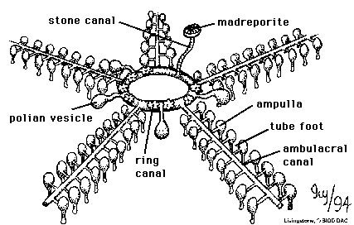
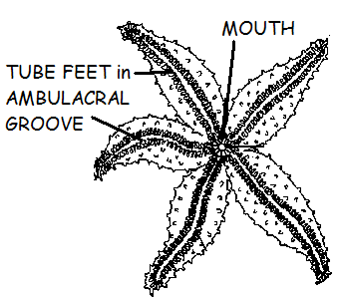
The TUBE FEET are located in the AMBULACRAL GROOVE which runs from the tip of each arm to the mouth. In many species, muscles in the tube feet can create suction when the foot is pressed against a surface. This allows the starfish to crawl along a surface or grab onto and open bivalve shells. The TUBE FEET are controlled by water pressure moving in the WATER VASCULAR SYSTEM.

WATER VASCULAR SYSTEM
the WATER VASCULAR SYSTEM is unique
to ECHINODERMS. It is a system of tubes that
use hydraulic (water) pressure to operate suction
cupped TUBE FEET. Water enters the system
through small pores in the MADREPORITE,
a sieve-like opening on the ABORAL surface. Water
then passes down the STONE CANAL (so called because it contains CALCIUM CARBONATE) to the RING CANAL, which encircles the MOUTH. A RADIAL CANAL (also called AMBULACRAL CANAL) extends from the ring canal into each arm and is protected by the AMBULACRAL RIDGE. The upper end of each tube foot is expanded to form a bulb-like sac called an AMPULLA (pl. AMPULLAE) Contraction of muscles in the ampullae and along the tube feet contract to control water entering and leaving the tube feet. In this way a starfish uses water pressure to extend and withdraw its tube feet, which it uses for LOCOMOTION and to CAPTURE FOOD.
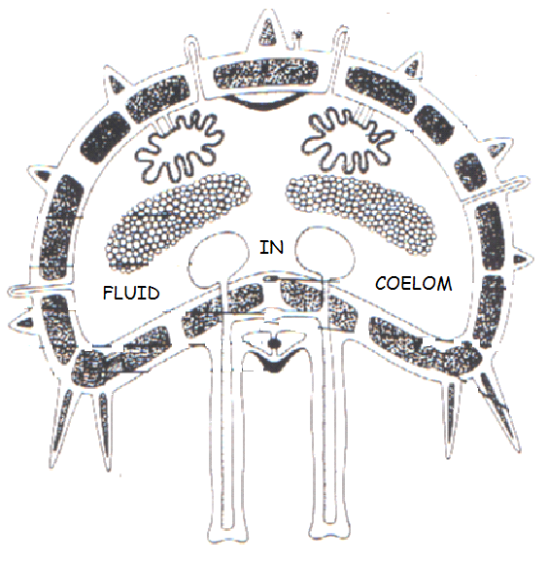
CIRCULATORY: (OPEN)
Starfish have an OPEN circulatory system with NO HEART or BLOOD VESSELS. BLOOD (HEMOLYMPH) in the coelom (HEMOCOEL) bathes the organs and distributes nutrients and oxygen.

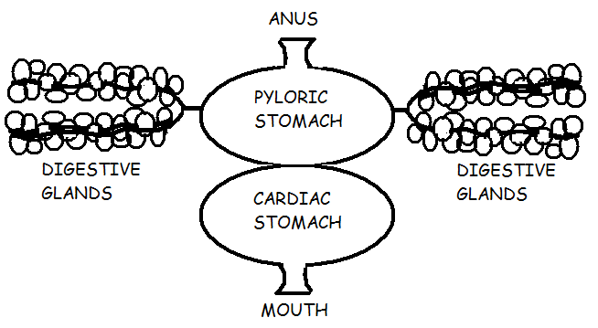
DIGESTIVE: The sea star’s mouth is connected by a short ESOPHAGUS to the CARDIAC STOMACH, which is turned inside out through the mouth during feeding. Digestion begins outside the body until the cardiac stomach is pulled back inside.
The cardiac stomach transfers food
to the PYLORIC STOMACH, that which
connects to a pair of DIGESTIVE GLANDS
in each arm. The two stomachs and the
digestive glands use digestive enzymes to
break down food. The greenish color comes
from BILE which helps breakdown FATS.
Nutrients are absorbed through the walls of the
DIGESTIVE GLANDS into the COELOM and undigested
food is passed out of the body through the ANUS on the
ABORAL surface. THERE IS NO INTESTINE IN A STARFISH!

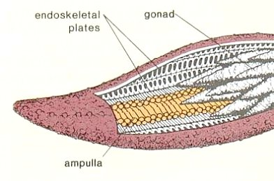
REPRODUCTIVE: (SEXUAL and ASEXUAL)
Most Echinoderms have SEPARATE SEXES and their paired reproductive organs (GONADS) can be seen extending into each of the arms underneath the digestive glands. The size of the gonads depends on the phase of the breeding cycle.

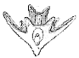

EXTERNAL FERTILIZATION occurs when eggs or sperm are released
into the water through PORES on the ABORAL surface. Starfish show
INDIRECT development, hatching as an immature BILATERALLY SYMMETRICAL
winged BIPINNARIA LARVA and maturing into a RADIALLY symmetrical ADULT.

AUTOTOMY/REGENERATION:
Starfish are relatively simple animals that show a remarkable power of regeneration. Any piece of the starfish containing a part of the ring canal can regenerate the lost portion of the body. Like Planaria, these organisms can use their powers of regeneration for ASEXUAL REPRODUCTION. Starfish can also use this ability as a defense mechanism by automatically shedding an arm (AUTOTOMY) at its base if grabbed by a predator and growing it back later (REGENERATION). Regeneration is slow requiring about a year.
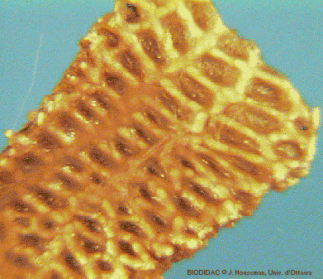
SKELETAL
Echinoderms display the beginnings of an internal ENDOSKELETON. A framework made of calcium plates called OSSICLES can be seen inside the coelom running through the body wall. The largest ossicles form the ambulacral ridge inside each arm which supports the ambulacral groove and provides attachment for the tube feet.
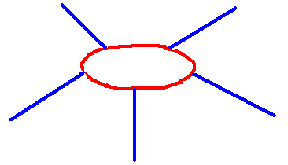
NERVOUS:
The nervous system in a starfish is primitive. Since they have no head (NO CEPHAPLIZATION), they also have no brain or cerebral ganglia. The nervous system consists of a NERVE RING that encircles the mouth which connects to RADIAL NERVES that run from the nerve ring along the length of each arm inside the AMBULACRAL RIDGE. Arm movement is controlled by GANGLIA at the junction of each radial nerve and the nerve ring. If the radial nerve is cut in one arm, the tube feet in that arm lose coordination. If the nerve ring is cut, the feet in all arms lose coordination and the starfish can’t move. Other nerve centers control the stomach, tube feet, and ampullae. Sea stars also have a NERVE NET in the skin near the body surface that controls the movements of the spines, pedicellariae, and skin gills. The end of each arm has a red pigmented eye-spot that can sense light. Touch and chemical sensitive cells are scattered over the surface of the sea star’s body.

CRAYFISH DISSECTION
KINGDOM: Animalia
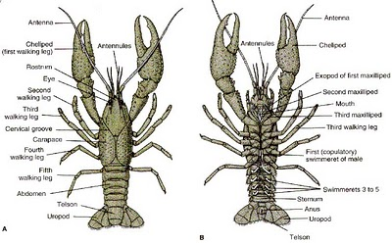
PHYLUM: ARTHROPODA “jointed foot”
CLASS: CRUSTACEA “flexible shell”

Three-fourths of all animal species belong to the PHYLUM
ARTHROPODA. This group of INVERTEBRATE PROTOSTOMES
includes a diverse assortment of BILATERALLY SYMMETRICAL
EUCOELOMATES: including lobsters, crabs, spiders, millipedes,
centipedes, and insects. Crayfish are found in freshwater ponds,
lakes, and streams. Crayfish are DECAPODS (10 legs)with four
pairs of WALKING LEGS and two CHELIPEDS (claws) used for
defense and catching food.

EXAMINE THE EXTERIOR:
The phylum gets its name from its distinctive jointed appendages, which may be modified in a number of ways to form:
ANTENNAE -feelers for touch and taste
ANTENNULES-feelers for touch, taste, and EQUILIBRIUM
SWIMMERETS create water currents over embryos;
transfer sperm (males); carry developing embryos (females);
MANDIBLES -chew food
MAXILLAE (2 pairs) - manipulate food;
last pair= BAILERS-keep water moving over gills
MAXILLIPEDS (3 pairs)- touch, taste, and manipulate food

Crayfish have the ability to self-amputate (AUTOTOMY) and re-grow (REGENERATION) damaged appendages for defense and repair. However, they cannot re-grow a whole organism from the parts.

INTEGUMENTARY/SKELETAL
Crayfish have a sturdy EXOSKELETON secreted by the epidermis composed of CHITIN, a nitrogenous carbohydrate bound with PROTEINS and hardened with CALCIUM CARBONATE. The exoskeleton is shed as it is outgrown. Like the annelids (earthworms) that you studied, arthropods are SEGMENTED animals.

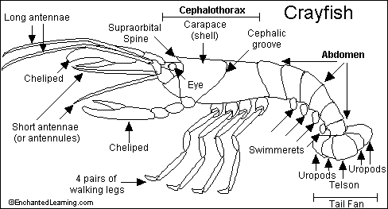
In arthropods some of the segments are fused together to form a larger structure called a TAGMA (pl. TAGMATA). The body of a crayfish is divided into 2 major sections: CEPHALOTHORAX and ABDOMEN.
An example of a TAGMA is the CEPHALOTHORAX in a crayfish. The head and middle body sections (thorax) are joined together to make one piece. You can see the fused dividing line between them. The portion of the exoskeleton that covers the cephalothorax is called the CARAPACE.

The visor-like ROSTRUM covers and protects the eyes.
Locate the TELSON (center paddle) and UROPODS (used in propulsion) of the tail.

MUSCULAR SYSTEM.
Strong ADDUCTOR muscles attach to the EXOSKELETON and operate the mouthparts. MUSCLES attach to the inside of the exoskeleton on either side of the joints, move the body segments. Powerful MUSCLES in the abdomen can bend the abdomen suddenly (called a tail flip) propelling the animal backwards. Crayfish also use their walking legs to get around,
ENDOCRINE SYSTEM
The endocrine glands release hormones into the blood which control other body functions, such as molting, sexual development, and regulation of heart rate.

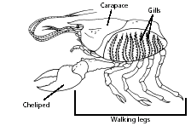
RESPIRATORY
Remove the CARAPACE to see the gills underneath. Crayfish have GILLS for exchange of gases (oxygen and carbon dioxide). The gills attach at the base of the WALKING LEGS and extend into a cavity under the CARAPACE which is separated from the body by an internal divider. As a crayfish walks, the WALKING LEGS circulate water across its gills. The posterior pair of MAXILLAE called “BAILERS”, also helps in respiration by keeping water moving over the gills.

DIGESTIVE
Crayfish are scavengers. They eat just about anything… dead or alive. CHELIPEDS are used to capture food. The MAXILLA and MAXILLIPEDS help move the food to the MOUTH. Food is chewed with its MANDIBLES. Food passes through the ESOPHAGUS into the 2-part STOMACH (CARDIAC & PYLORIC) where the GASTRIC MILL (teeth made of CHITIN and CALCIUM CARBONATE) grinds it into a fine paste. The DIGESTIVE GLAND (simple liver) near the stomach produces enzymes to break down undigested food. The digestive gland is also the main site of absorption of nutrients. The greenish color comes from BILE which helps breakdown FATS. Indigestible waste leaves the body through the ANUS near the TELSON.

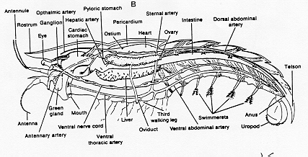
CIRCULATORY
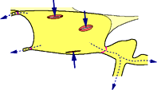
Crayfish have an OPEN circulatory system. Hemolymph leaves the DORSAL HEART in large VESSELS (ARTERIES) which carry it to different parts of the body, but there are NO RETURNING VESSELS (VEINS). The blood leaves the vessels and enters the HEMOCOEL (BODY CAVITY) where it bathes the tissues. It passes through the gills where it exchanges oxygen and carbon dioxide with the water. From there it returns to the dorsal part of the crayfish and reenters the heart through openings called OSTIA (sing. OSTIUM).

EXCRETORY
Since plenty of water is available, crayfish can excrete their nitrogen waste in the most toxic form as AMMONIA. It is released through the GILLS. GREEN GLANDS also regulate water and ion concentration (OSMOREGULATION). These glands are green in fresh specimens, but are usually yellow in preserved specimens. Because crayfish live in freshwater (a HYPOTONIC environment), water is constantly entering their tissues. The green glands collect ammonia and excess water and excrete it through pores at the base of the ANTENNAE.

NERVOUS
The nervous system of a crayfish is similar to that seen in earthworms. The crayfish’s brain is a pair of CEREBRAL GANGLIA above the ESOPHAGUS that receives impulses from the eyes, antennules, and antennae. Two bundles of nerve fibers extend from the brain around the esophagus on either side to a GANGLION that controls the mouth parts. A VENTRAL NERVE CORD runs along on the underside connecting to multiple GANGLIA along body that control the appendages and muscles in the abdomen and thorax. Crayfish have COMPOUND EYES set on short stalks. Each eye has over 2000 light-sensitive units each with its own lens. The ANTENNAE and ANTENNULES are sensitive to TASTE and TOUCH. The ANTENNULES also detect changes in EQUILIBRIUM. Crayfish can sense vibrations and chemicals in the water with thousands of small sensory hairs that project from their exoskeleton.

REPRODUCTION
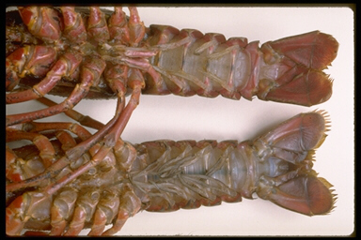
Crayfish have SEPARATE SEXES. They are either MALE with TESTES for making sperm or FEMALE with OVARIES for making eggs. The GONADS (reproductive organs) are located underneath the heart.

In females OVARIES make eggs and in males TESTES make sperm. You may be able to see the tiny tubules for carrying sperm (VAS DEFERENS).

In males the first two pairs of SWIMMMERETS are modified to transfer sperm to the female.
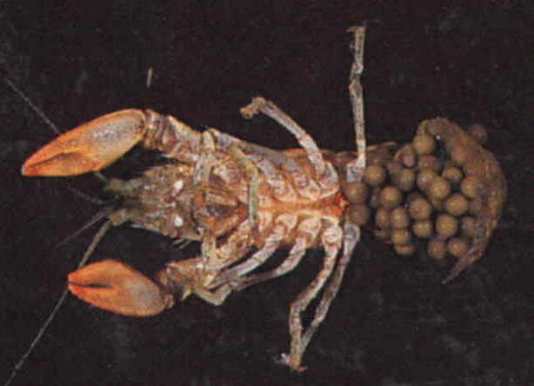

Mating takes place in the fall. Females store sperm in a SEMINAL RECEPTACLE (opening between the back walking legs). Fertilization in crayfish is EXTERNAL. Sperm is stored throughout the winter and used to fertilize the eggs when they are released the following spring. A single female can lay from 100-600 eggs. The developing embryos are carried on the female’s SWIMMERETS until they mature. Females carrying developing embryos are said to be
“IN BERRY”.

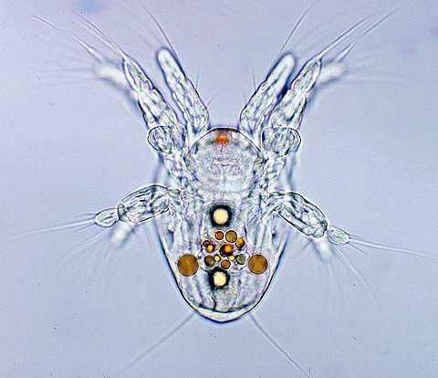
CRUSTACEANS have INDIRECT DEVELOPMENT. They start life as a free swimming NAUPLIUS larva with 3 pairs of appendages and a single eye in the middle of its body.

PERCH DISSECTION
KINGDOM: Animalia
PHYLUM: Chordates
SUBPHYLUM: VERTEBRATA “bone covering nerve cord”
CLASS: OSTEICHTHYES ‘bony fish”

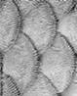
Fishes are the oldest VERTEBRATE group and the most numerous and widespread of all living vertebrates today. Like all vertebrates, fish are DEUTEROSTOMES. 95% of all fish are in the class OSTEICHTHYES meaning “bony fish”. All BONY FISH have three characteristics:
1). an ENDOSKELETON made of BONE
2.) LUNGS or a SWIM BLADDER
3.) a body surface covered with SCALES

INTEGUMENTARY:
The skin of the perch is covered with SCALES (thin round discs of bonelike material that grow from pockets in the skin). The scales overlap like roof shingles and point toward the tail in order to reduce friction as the fish swims. Scales grow throughout the fish’s life and the resulting growth rings give a good approximation of the fish’s age. Scales also provide protection.

The fins on a fish are adaptations for swimming and navigation and are supported by RAYS or SPINES which also provide protection from predators.
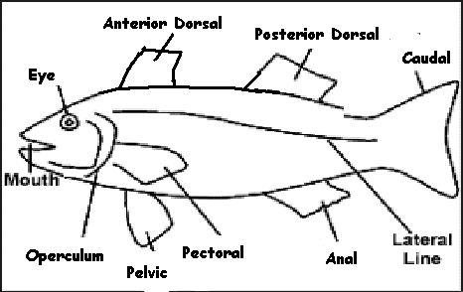
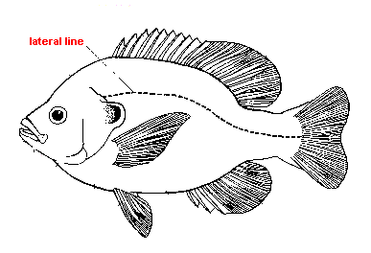
The two DORSAL FINS (one anterior and one posterior) and a ventral ANAL FIN help keep the fish upright and moving in a straight line. The paired PELVIC FINS and PECTORAL FINS are used to stop, move up and down, and even back up. The CAUDAL FIN extends from the tail for propulsion. The ANUS and UROGENITAL OPENING are located near the anal fin.
NERVOUS (Sense organs)
The LATERAL LINE system, which runs along each side of the fish, is a sensory structure which detects water pressure and vibrations in the water. Find the NOSTRILS (dead end pockets) and EYES (with NO EYELIDS).

Fish have a highly developed sense of smell and sight and the parts of the fish’s brain that process info from these two areas (OPTIC TECTUM and OLFACTORY LOBES) are the largest parts of a fish’s brain.

COLORATION:
Pigment cells (CHROMATOPHORES) in the skin give the fish its color and allow it to blend in with its surroundings. Notice the fish has lighter coloration on its ventral surface and is darker on the top so it is less easily seen from above or below.
RESPIRATORY/EXCRETORY:
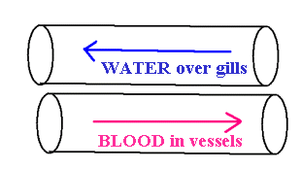
On each side of the head is the OPERCULUM, a hard plate that covers and protects the GILLS. Water enters through the fish’s mouth, passes over the gills, and out through the slits behind the OPERCULUM.
Water moving over the gills flows away from the head, while the blood inside the gills flows toward the head. This arrangement, known as COUNTERCURRENT FLOW, allows more oxygen to diffuse into the gills than would be possible if blood and water both flowed in the same direction.

The GILLS in a fish serve THREE FUNCTIONS:
1. EXCHANGE OF GASES (oxygen is taken in and carbon dioxide is released),
2. REMOVAL OF NITROGEN WASTE
(AMMONIA is removed from blood and released into the water
3. OSMOREGULATION OF WATER/ION CONCENTRATION IN BLOOD
(IONS are actively transported IN or OUT depending on environment)
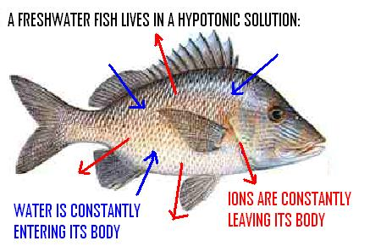
In order to stay alive an organism must keep the balance of ions and water in a constant range. This is done through a process called OSMOREGULATION, which means maintaining the proper balance of water and ions in the blood and body tissues.

FRESHWATER FISH:
Freshwater fish tend to GAIN WATER and LOSE IONS
in their HYPOTONIC environment.

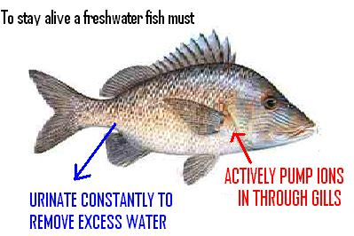

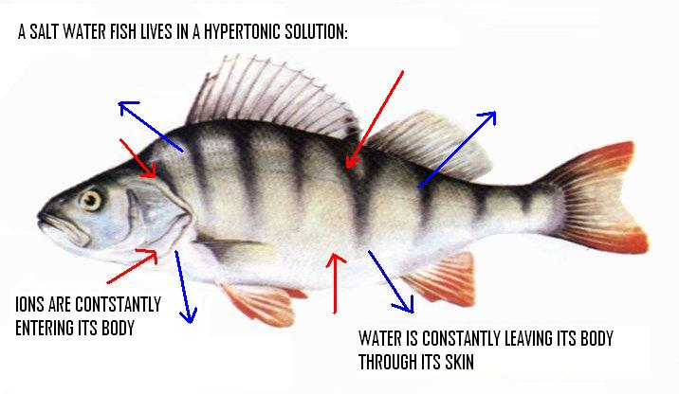
The GILLS in a perch (freshwater dweller) have special cells that ACTIVELY TRANSPORT sodium and chloride ions in through the gills to maintain the correct ion balance. The KIDNEYS also remove excess water by making urine. Freshwater fish urinate constantly to remove the excess water that is always entering their bodies from their hypotonic
environment.

SALTWATER (MARINE) FISH:
The reverse happens in SALT-WATER fish. Since sea water is HYPERTONIC, water is constantly leaving the fish’s body via osmosis and ions are entering through diffusion.
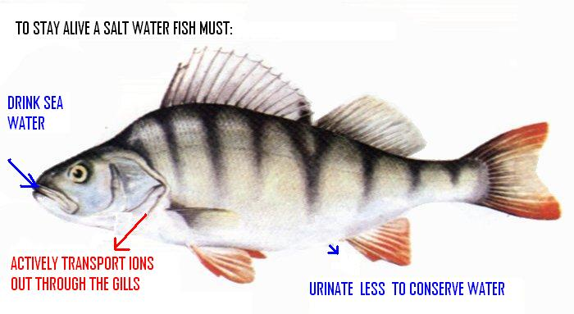
To maintain the water/ion balance, salt water fish urinate less and drink sea water to replace lost water. They excrete the extra ions taken in through special cells in their gills that maintain the proper osmotic concentration in their blood and tissues. Extra ions are also excreted in urine.

INTERNAL ORGANS: Use your scissors to slice along the ventral surface and peek inside to see the SWIM BLADDER (also called AIR/GAS BLADDER). This organ is thought to have evolved from the lungs of early bony fish. Gases (oxygen, carbon dioxide, and nitrogen) from the blood can be added to or removed from the SWIM BLADDER to control the fish’s buoyancy. By adjusting the volume of gas in the swim bladder, a fish can remain suspended at any depth with no muscular effort.

MUSCULAR/SKELETAL
Fish are “top heavy” with muscle because the body muscles are concentrated along the dorsal surface and in the tail of your fish. (One of the reasons fish float “belly up” when they are dead). An ENDOSKELETON of bone provides support and helps in movement. Having an ENDOSKELETON allows a vertebrate to grow without molting. Bones (called vertebrae) surround their SPINAL CORD, as well.

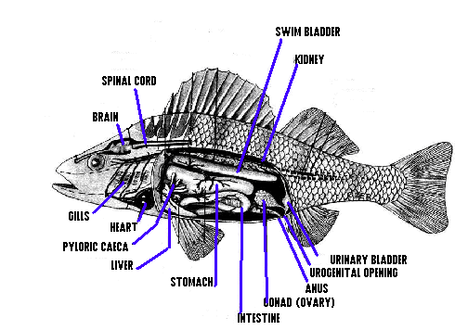
Place your fish on its RIGHT SIDE and remove the body wall on the left side of your fish so you can see the internal organs. Fish, like all VERTEBRATES, are EUCOELOMATES and DEUTEROSTOMES. The space you see surrounding the organs is true COELOM. Notice the location of the liver, gills, and heart. It is no accident these vital organs are so close together.

REPRODUCTIVE
Fish have SEPARATE SEXES. The male reproductive system consists of paired TESTES that produce sperm which are carried by the VAS DEFERENS to the shared UROGENITAL OPENING that releases both urine and eggs or sperm. In females eggs are produced in paired OVARIES and carried via OVIDUCTS to the UROGENITAL OPENING. Eggs and sperm are released through this UROGENITAL opening behind the ANUS. Most fish have EXTERNAL FERTILIZATION. The female lays eggs and the male passes over them, depositing the sperm to fertilize them. Mortality among eggs and young is high and fish lay large numbers of eggs to ensure at least some will survive. Immature fish that hatch are called FRY. Many fish display complex reproductive behaviors (SPAWNING) for courtship, nest building, migrating, and caring for young.

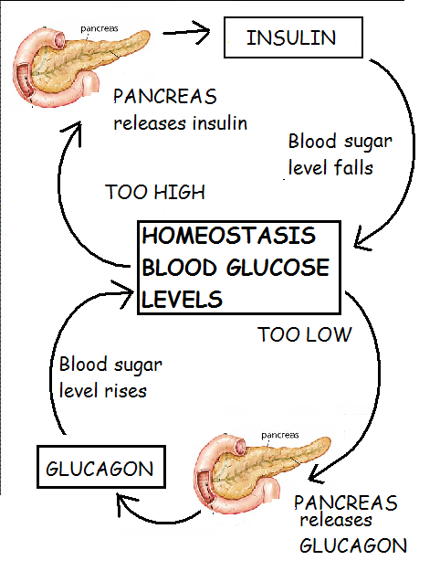
DIGESTIVE
Examine the MOUTH and PHARYNX (opening to the digestive system in the back of the throat). The ESOPHAGUS is a short muscular tube that connects the pharynx and the STOMACH which produces acid and some digestive enzymes to begin the breakdown of food. The CARDIAC STOMACH is closest to the mouth. The PYLORIC STOMACH connects to the INTESTINE. The PYLORIC CAECA pouches located near the junction of the PYLORIC STOMACH and the DUODENUM (lst part of INTESTINE). VILLI (fingerlike extensions along the inside surface of the intestine) help to INCREASE SURFACE AREA for better nutrient absorption by the intestine. The PYLORIC CAECA are believed to be involved in digestion of plants and absorption of nutrients. Digestive waste moves through the intestine and exits the body through the ANUS. The reproductive organ and KIDNEYS also exit in this area through the shared UROGENITAL OPENING.

The LIVER lies on top of the STOMACH. It secretes BILE (to help digest fats) which is stored in the GALL BLADDER (darker tissue on the LIVER) until it is used in the INTESTINE. In addition to SECRETING BILE, the liver also functions in GLYCOGEN STORAGE, VITAMIN STORAGE, and PROCESSES TOXINS (including NITROGEN WASTE from the body cells) which are then removed from the blood by the KIDNEYS and GILLS (as AMMONIA). The PANCREAS makes a digestive enzyme called TRYPSIN (that breaks down proteins) which is released into the intestine.

ENDOCRINE
The endocrine system controls sexual development, heart rate, and metabolism. In addition to digestive enzymes (trypsin), the PANCREAS makes two endocrine hormones that regulate
blood sugar levels. INSULIN causes cells to take up glucose from the blood stream and store it as glycogen. GLUCAGON causes cells to release their stored glycogen as glucose into the bloodstream. These to hormones work together to control blood sugar levels.
(Remember that HOMEOSTASIS thing?)

CIRCULATORY
The circulatory system in a fish delivers oxygen and nutrients to the cells of the body. It also transports carbon dioxide and nitrogen waste to the gills and kidneys for elimination. The circulatory system consists of a HEART, BLOOD VESSELS, and BLOOD. Fish have a CLOSED circulatory system with blood contained in blood vessels. The heart pumps blood in a SINGLE CLOSED loop through ARTERIES (vessels that carry blood away from the heart) to small thin walled vessels in the GILLS called CAPILLARIES where oxygen is picked up and carbon dioxide is released. From the gills, blood travels to the tissues where nutrients and wastes are exchanged via capillary walls. Blood returns to the heart in vessels called VEINS.
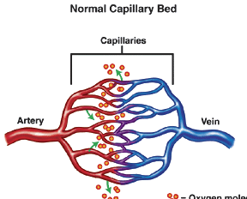

The heart in a fish has 2 MAIN CHAMBERS: an ATRIUM and a VENTRICLE. Deoxygenated (low oxygen) blood returning to the heart empties into a collecting space called the SINUS VENOSUS before moving into the ATRIUM. Contraction of the atrium speeds up the blood and drives it into the VENTRICLE (main pumping chamber). Contraction of the ventricle forces the blood through the circulatory system. An exit space called the CONUS ARTERIOSUS smoothes the flow of blood as it leaves the heart.
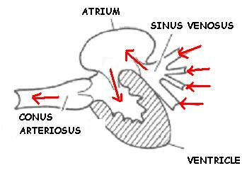

From BODY
To GILLS

The SPLEEN is a dark thin structure that lies in the loops of the INTESTINE near the CARDIAC STOMACH and functions in red blood cell formation, destruction, and storage. During times of low oxygen the spleen can release extra red blood cells to carry more oxygen.

EXCRETORY
The KIDNEYS are dark colored tissue located on the dorsal body wall inside the COELOM. (NOTE: Run your finger along the ceiling of the coelom space. The bone surrounding the SPINAL CORD creates a “bumpy” surface. ) The function of the kidneys is to REMOVE NITROGEN WASTE (ammonia and urea) from the blood that has been produced and processed by the LIVER. AMMONIA, the major nitrogen waste product, is highly TOXIC (poisonous) and must be diluted with large amounts of water. The kidneys do this by making URINE, which contains AMMONIA, IONS (like sodium and chloride) and WATER. Urine is produced by kidneys and stored in the URINARY BLADDER. Urine passes out through the UROGENITAL PORE behind the ANUS. Remember sperm and eggs also use this shared opening!

The kidneys also function along with the GILLS in OSMOREGULATION to remove excess water that enters the body via osmosis and keep the correct balance of ions in the blood and tissues. Freshwater fish urinate constantly (up to 30% of their body weight daily) to remove the excess water that is always entering their bodies due to the HYPOTONIC environment in which they live.

MARINE (salt water) fish have the opposite problem. Because they live in a HYPERTONIC environment, water is always leaving a marine fish’s body. They urinate very little and must drink sea water and actively excrete the ions out through their gills in order to maintain their osmotic balance.

NERVOUS
The nervous system in a fish includes the BRAIN, SPINAL CORD, NERVES that lead to and from all the parts of the body, and various SENSORY ORGANS. Fish are VERTEBRATES with a DORSAL NERVE CORD running along the dorsal body wall. A nerve cord covered with bone is called a SPINAL CORD. The brain in a fish is more complex than you have seen in invertebrates.
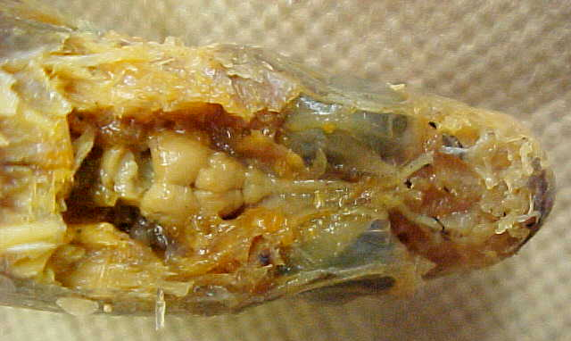
THE BRAIN consists of several areas with different functions. Fish have a highly developed sense of smell and sight and the parts of the fish’s brain that process info from these two areas (OPTIC TECTUM and OLFACTORY LOBES) are the largest parts of a fish’s brain. The most anterior part are the OLFACTORY LOBES which process info for smell. The CEREBRUM is for higher thinking (learning, memory, and problem solving) and integrates information from all the other areas of the brain. The largest part is the OPTIC TECTUM, which receives and processes information from the fish’s visual, auditory {hearing}, and LATERAL LINE systems. The most posterior portions are the CEREBELLUM (controls motor coordination & balance), and the MEDULLA OBLONGATA (controls autonomic body organs and acts as a relay station for information from sensory receptors throughout the body). The SPINAL CORD is surrounded by vertebrae, extends along the body, and carries nerve impulses to and from the brain.

FROG DISSECTION
PHYLUM: Chordata
SUBPHYLUM: VERTEBRATA “bone covering nerve cord”
CLASS: Amphibia “double life”
ORDER: Anura “without a tail”

About 370 million years ago, the first amphibians evolved from lobe-finned bony fish and became the first vertebrates to live on land. Like other VERTEBRATES, amphibians are DEUTEROSTOMES.

INTEGUMENTARY
The skin of a frog serves two functions: protection and respiration. Breathing through the skin is called CUTANEOUS respiration. THIN, MOIST skin is very permeable, allowing rapid diffusion of gases. MUCOUS GLANDS in the skin help keep the skin moist in air and make a frog feel “slimy”. In some amphibians, the skin contains other glands that secrete foul-tasting or poisonous substances that provide protection from predators. However, the same features that allow efficient respiration, make the frog vulnerable to dehydration. So amphibians live in moist, wet places on land and are active at night when loss of water through evaporation is reduced. Coloration in an amphibian’s skin provides camouflage.
Notice the WEBBED FEET on the back legs. One of the characteristics of AMPHIBIANS is feet with NO CLAWS.

WHAT SEX IS IT?
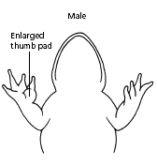
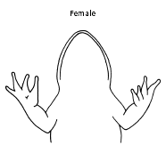
Male frogs are usually smaller than females and have thick “THUMB PADS” which enable the male to hold onto the female so that sperm and eggs are released at the same time and in the same place (AMPLEXUS). This increases the chances for EXTERNAL fertilization. Locate the exit opening between the frog’s hind legs. This is the opening to the CLOACA, a multipurpose cavity shared by the digestive, reproductive, and excretory systems. In animals with a cloaca, the exit opening is called a VENT.

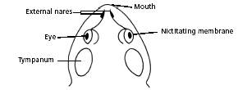
Locate the structures shown in the diagram at the left. The NICTITATING MEMBRANE, is a transparent third eyelid, which covers and protects the eye while swimming under water.
The TYMPANIC MEMBRANES (eardrums) are located directly behind the eyes. A bone called the COLUMELLA transmits sound from the eardrum to the inner ear. EUSTACHIAN TUBES connect the inner ears to the mouth cavity. The EXTERNAL NARES (nostrils) also connect inside to the mouth so frogs can breathe with their mouths closed while swimming.
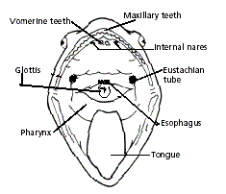
CUT THE HINGES TO THE MOUTH AND LOOK INSIDE to find the following:

A flexible TONGUE is attached at the front rather than in the rear like ours.Two INTERNAL NARES (connect to EXTERNAL NARES outside) which allow the frog to breathe with its mouth closed.

Two VOMERINE TEETH in the middle of the roof of the mouth and the MAXILLARY TEETH along the jaw, which grab and hold prey to keep it from escaping. Frogs don’t chew, but swallow their food whole.

The GLOTTIS, a small round structure with a vertical slit just behind the TONGUE, is the opening to the respiratory system. Posterior to the glottis is the opening to the esophagus and the digestive system. The muscular back of the throat where food is pulled into the digestive system is the PHARYNX. The opening where food enters the digestive system is the GULLET.

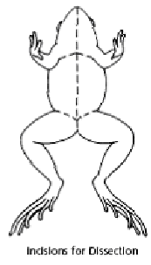
Follow the diagram at the left and cut through the skin only.
Notice the numerous BLOOD VESSELS in the skin for gas exchange.

Frogs are true EUCOELOMATES. If your frog is female, the abdominal cavity (COELOM) may be filled with black and white eggs. Amphibian eggs are surrounded by a single cellular membrane and are coated with a jelly-like material as they are laid for protection.

The yellowish fingerlike structures are FAT BODIES. Frogs do not store fat in layers under the skin like humans do. The size of the fat bodies varies depending on the season. These are reservoirs for food used during HIBERNATION, ESTIVATION, and breeding.

Amphibians, as well as the other organisms we have dissected so far, are ECTOTHERMIC; commonly called “cold blooded”. They don’t make their own body heat. Their body temperature is dependent on the temperature of their environment. Animals that are ectothermic have evolved ways to survive in environments with seasonal extremes in temperature. Many animals hibernate in order to stay alive in cold times (winter season) and many amphibians (like frogs and toads) ESTIVATE [or aestivate] in HOT, DRY conditions. When hot and dry times come, estivators will find themselves a safe place to sleep--usually underground. This is the only way some animals can live through conditions with high heat and no water. The metabolism, breathing and heartbeat slow down. The animal doesn't need as much food and water to live. Animals don't move, grow or eat during this time. Fat stored in the FAT BODIES provides energy for the animal during estivation, hibernation, and breeding seasons.
DIGESTIVE SYSTEM Use the diagram to locate the following:
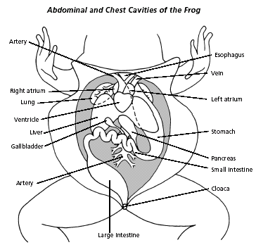
ESOPHAGUS- connects the mouth and stomach. The elastic esophagus and STOMACH (found under the lobes of the liver) allow the frog to swallow large amounts of food. Gastric juices secreted by the walls of the stomach and the muscles in the work to break down food. The circular PYLORIC SPHINCTER muscle at the end of the stomach controls the passing of digested into the SMALL INTESTINE.

The upper portion of the SMALL INTESTINE closest to the stomach is the DUODENUM. The coiled middle section is the ILEUM. A fan-like membrane called the MESENTERY holds the folds of the small intestine together. The SMALL INTESTINE receives bile from the LIVER and pancreatic enzymes (including trypsin) from the PANCREAS. Digestion is completed here and nutrients are absorbed through the surface of the small intestine lined with VILLI, the finger-like extensions which increase surface area. The lower end of the small intestine leads into the LARGE INTESTINE, where indigestible wastes are collected and passed into the CLOACA, a multipurpose cavity. Waste from the kidneys (urine), as well as eggs OR sperm also pass through the cloaca on its way out of the body. Waste materials exit through the VENT.

The LIVER consists of three dark lobes. Its main functions are to MAKE BILE, STORE VITAMINS, STORE GLYCOGEN, and PROCESS TOXINS (including NITROGEN WASTE) which the kidneys remove. THE GALL BLADDER stores BILE made by the liver. It is a greenish colored sac found between the left and right lobes of the liver. PANCREAS is an elongated yellow organ located in the first loop of intestine between the small intestine and stomach. It secretes TRYPSIN (used in the small intestine to break down proteins) and enzymes to regulate blood glucose levels. INSULIN causes cells to store glucose as GLYCOGEN and GLUCAGON causes cells to release stored glucose into the blood stream.
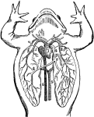
RESPIRATION:
Adult frogs breathe in two ways. The respiratory organ in the adult frog is LUNGS (two large air sacs below the liver and heart). Breathing with lungs is called PULMONARY RESPIRATION. Adult frogs also breathe through the skin on their bodies (CUTANEOUS RESPIRATION) and through the skin in their mouths. Raising and lowering the floor of mouth, opening and closing nostrils pushes air into the lungs (called positive pressure breathing).

The respiratory organ in tadpoles is the GILLS. As tadpoles undergo METAMORPHOSIS they grow lungs and must change from breathing with gills to breathing with lungs.
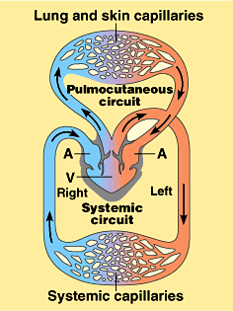
CIRCULATORY SYSTEM
While TADPOLES have a CLOSED circulatory system similar to fish (TWO CHAMBERS/1 LOOP) adult amphibians have a CLOSED 3 CHAMBER/2 LOOP circulatory system. The heart is surrounded by a PERICARDIAL MEMBRANE. Locate the RIGHT ATRIUM, LEFT ATRIUM, and VENTRICLE. The PULMONARY CIRCULATION carries deoxygenated (LOW oxygen) blood from the heart to the lungs and returns oxygenated (HIGH oxygen) blood to the heart. ARTERIES carry blood leaving the heart and veins carry blood returning to the heart from the body. Capillaries connect arteries and veins and allow gas exchange in the lungs and body tissues. Adding a second loop has the advantage of “faster blood flow to the body organs”. Low oxygen blood enters the SINUS VENOSUS from the large vein bringing blood back to the heart (VENA CAVA) from the body. From there it enters the RIGHT ATRIUM. At the same time high oxygen blood returning from the lungs via the PULMONARY VEINS enters the LEFT ATRIUM. When the atria contract both kinds of blood are sent to the VENTRICLE. Although the ventricle is not divided, a spongy irregular surface inside, the coordinated contractions of the 2 atria, and a valve in the conus arteriosus keep the HIGH and LOW OXYGEN blood from mixing, even though both kinds of blood share this single pumping chamber. When the ventricle contracts, high oxygen blood is sent into the CONUS ARTERIOSUS, that has a valve to prevent mixing of the high and low oxygen blood. High oxygen blood is carried via a large artery (AORTA) out to the body organs and muscles and low oxygen blood is sent to the lungs to pick up oxygen via the PULMONARY ARTERIES.
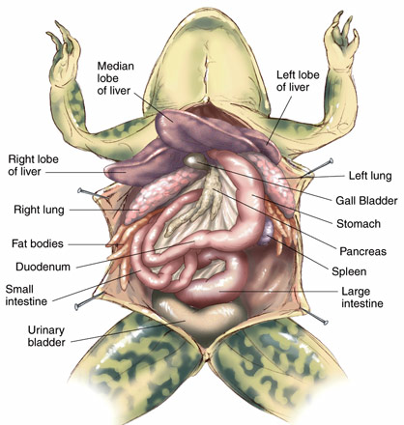
SYSTEMIC CIRCULATORY SYSTEM
The SYSTEMIC CIRCULATION carries oxygenated blood from the heart to the muscles and body organs and brings deoxygenated blood back to the heart. Parts of the SYSTEMIC system are named for the organs they service. RENAL circulation carries blood to the kidneys. The CORONARY circulation supplies blood to the heart itself. The HEPATIC circulation carries blood to the liver.

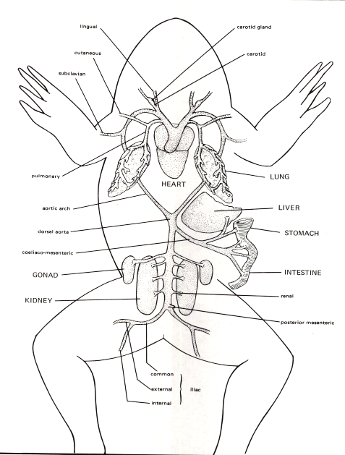
EXCRETORY
Like fish, most amphibian larvae excrete nitrogen waste as AMMONIA through their gills. Ammonia is HIGHLY TOXIC and must be excreted quickly (through their gills) or diluted with large amounts of water to make urine. IN ORDER TO CONSERVE WATER terrestrial ADULT amphibians transform their ammonia into UREA, which is less toxic and does not require as much water to dilute.

The KIDNEYS, which lie on either side of the spine against the dorsal body wall, are the primary excretory organs. The kidneys filter NITROGEN WASTES (UREA) from the blood which is diluted with water to make URINE. Urine flows from the kidneys through urinary ducts to the CLOACA. The URINARY BLADDER, which branches from the ventral wall of the CLOACA, stores urine until it is released through the VENT. During dry periods, water can be reabsorbed from urine in the bladder.

ENDOCRINE
As we have seen, the endocrine system controls a variety of body functions including heart rate, metabolism (blood sugar levels), and sexual development. METAMORPHOSIS (changing form from a tadpole to an adult frog) is controlled by THYROXIN, a hormone produced by the THYROID GLAND. The PANCREAS makes insulin which causes cells to take up glucose from the blood stream and store it as glycogen and glucagon which causes cells to release their glucose into the blood stream.
REPRODUCTION
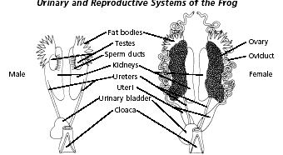
In amphibians, the excretory, reproductive, and digestive systems all share a multi-purpose exit space called a CLOACA. This space collects urine, eggs/sperm, and digestive waste before it exits the body. The exit opening in animals with a cloaca is called a VENT.

The female frog has paired OVARIES located near the kidneys, containing thousands of tiny eggs. During breeding season, the eggs enlarge, mature, and burst through the ovarian walls into the COELOM. Cilia move the eggs into OVIDUCTS, where they are coated with their protective jelly-like covering, and passed out of the body via the CLOACA through the VENT.

The male reproductive system includes 2 bean shaped TESTES located near the kidneys. Sperm cells develop in the testes and pass through tubules to the KIDNEYS, down the urinary ducts to the CLOACA, and out through the VENT.

As amphibians, frogs may live some of their adult lives on land, but must return to water to reproduce. In the first warm days of spring, frogs emerge from hibernation. Males call to attract females and to warn off other males. During mating the male grabs onto the female (AMPLEXUS) and holds on until eggs are released. Millions of sperm are released over the eggs to fertilize them. This firm grasp increases the chances that sperm will find egg and fertilization will occur. Eggs (2000-3000 at a time) are laid with a jelly-like coating, but have no shell or multicellular membranes.
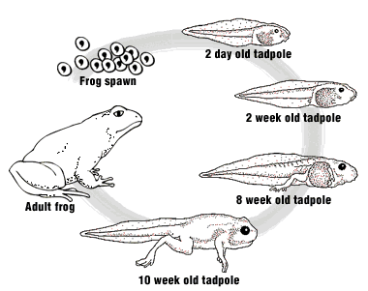
Most amphibians have INDIRECT DEVELOPMENT.
The larval form is a tadpole. A newly hatched tadpole lives off yolk stored in its body until its mouth opens and it can feed. The aquatic larvae breathe with gills and must undergo METAMORPHOSIS to become terrestrial, adult air breathers with lungs. Many land dwelling amphibians lay eggs in moist places on land such as under rocks, inside a rotting log, or in a tree.

An ENDOCRINE hormone called THYROXIN made by the thyroid gland stimulates these body changes. Legs grow, tail and gills disappear, lungs develop, the circulatory system changes from a fish’s one loop-two chambered heart to an adult’s two loop-three chambered heart.
TURTLE DISSECTION
PHYLUM: Chordata
SUBPHYLUM: VERTEBRATA “bone covering nerve cord”
Class: Reptilia “to creep or crawl”
Order: Chelonia “tortoise”

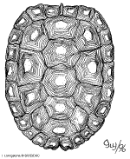
TURTLES and TORTOISES
Turtles have had over 200 million years to evolve and have outlived the dinosaurs to become one of the OLDEST LIVING families in the animal kingdom. The order CHELONIA consists of about 250 species of turtles and tortoises. The term tortoise is generally reserved for land dwellers, while turtle refers to chelonians that live in water. Like other VERTEBRATES, reptiles are DEUTEROSTOMES.

INTEGUMENT:
Because amphibians exchange gases through their skin, it must be moist and thin enough to allow rapid diffusion. One of the drawbacks of this kind of skin is the loss of body water through evaporation. The thick, dry, scaly skin of reptiles is an improvement, because it is water tight. The tough skin of a reptile helps to conserve water and protects the animal against infections, injuries, and the wear and tear associated with living on land. Surface cells fill with KERATIN, the same protein that forms your fingernails and hair and bird feathers. Lipids and proteins in the skin keep it watertight.

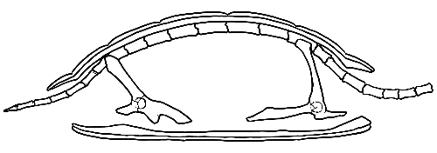
A turtle’s protective shell is formed from the fusion of bones from the ribs and vertebrae. The spine and ribs are attached to the shell, so turtles can’t really crawl out of their shells like in the cartoons. The bones of the shell are divided into sections called SCUTES, and are covered with skin containing a protein called KERATIN.
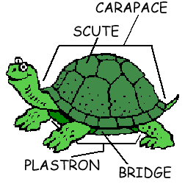
Scutes have nerve endings, so a turtle can feel something touching its shell. The scutes and the bone underneath can grow allowing the turtle to expand and get larger. Turtles can regenerate damaged scutes, and some scutes have rings similar to growth rings on trees that can be used to estimate age. The BRIDGE along the sides connects the CARAPACE (dorsal shell) to the PLASTRON (ventral shell).
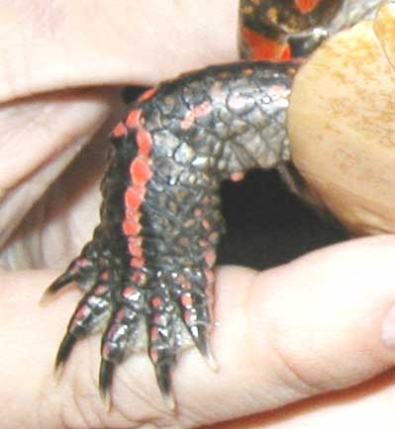

Locate the exit opening below the turtle’s tail. Like amphibians, the CLOACA, a multipurpose cavity shared by the digestive, reproductive, and excretory systems exits through a VENT.

One of the characteristics you saw in AMPHIBIANS (frogs)
was feet with NO CLAWS. Notice the CLAWED FEET in reptiles.

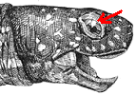
Like frogs, turtles have a NICTITATING MEMBRANE that acts as a third eyelid to cover and protect the eyeball under water. The TYMPANIC MEMBRANE (eardrum) is directly behind the eyes. Turtles have very poor hearing. The EXTERNAL NARES (nostrils) connect inside to the mouth just like in a frog. Unlike other reptiles, turtles have NO TEETH. Instead they have a sharp BEAK made of KERATIN.
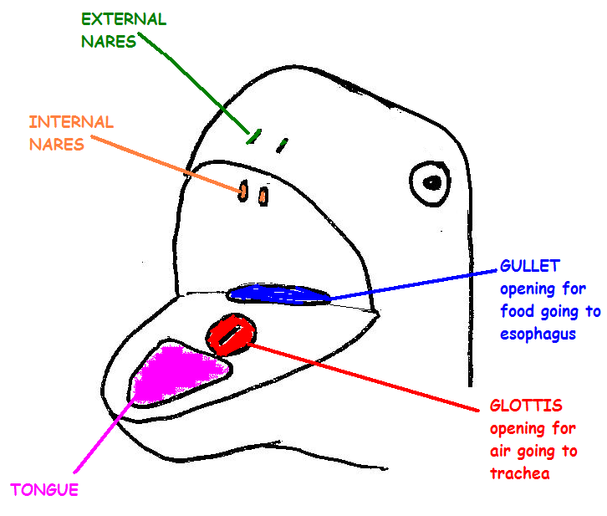

The structures inside the mouth of a turtle is very
similar to that seen in frogs. Two INTERNAL NARES
(connect to EXTERNAL NARES outside) which allow
the turtle to breathe with its mouth closed.
The GLOTTIS, a vertical slit just behind the TONGUE,
is the opening to the respiratory system. Behind the glottis
is the GULLET (the opening into the digestive system).

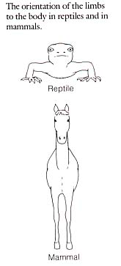

Reptiles have an unusual stance not seen in other animal groups. Their limbs protrude at right angles from their bodies. In all other animals with arms and legs, the shoulders and pelvic bones are OUTSIDE THE RIBCAGE.

In turtles the skeleton is modified so the LIMB GIRDLES (shoulders and pelvis) are located inside the RIBCAGE, This allows the turtle to pull its limbs inside its shell.

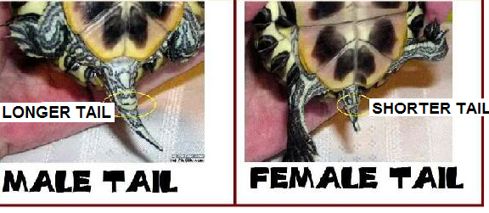
What sex is it?
Male turtles have longer front claws and a longer tail. The vent opening in males is farther back from the edge of their shell than in females. Their plastron is slightly concave to allow for males to climb on top of females during mating. In female turtles, the plastron is slightly convex to allow more room for eggs inside, the claws are shorter, the tail is shorter, and the vent opening is closer to the shell.

Reptiles are ECTOTHERMIC, commonly called “cold blooded”. They don’t make their own body heat. They maintain their body temperature (THERMOREGULATION) by absorbing heat from their environment. When it gets too warm they find a cool, shady spot. When they get too cool, they warm themselves by basking in the sun. ECTOTHERMS require very little energy because their metabolism is so low.

ADVANTAGES OF BEING ECTOTHERMIC: Because their metabolism is so slow, ectotherms can survive on about 1/10 the amount of food needed by the same size endotherm (warm blooded organism).

DISADVANTAGES OF BEING ECTOTHERMIC:
1). Ectotherms can run or swim at MAXIMUM SPEED FOR ONLY SHORT PERIODS of
time. (Their metabolism can’t provide enough energy to keep them going longer.)
2). Ectotherms CAN’T LIVE IN VERY COLD CLIMATES
They survive in moderate climates only by becoming dormant (HIBERNATING)
during the coldest months.

Because their body temperature is dependent on the temperature of their environment, reptiles are abundant in the warmer regions of the world, a few live in colder parts of the temperate zone, but none live in the Arctic or Antarctic regions.

REMOVE the PLASTRON: Be careful! This is a difficult and time consuming procedure! It will give you an appreciation for the armor that protects the turtle from most predators and which partially accounts for the long lives that turtles live. DO NOT USE YOUR KNIFE TO PRY OPEN THE SHELL . . . it will break. Use your steak knife to disconnect the skin around the legs to separate it from the shell.

Reptiles are EUCOELOMATES. The space you see surrounding the internal organs is “true coelom” (body cavity lined on both sides by mesoderm).

The yellowish structures are stored FAT. Turtles do not store fat in the same way as frogs do. Fat stores are reservoirs for food used during HIBERNATION. The MESENTERY (fan-like membrane) connects the internal organs just like in a frog.

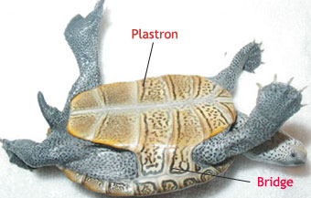

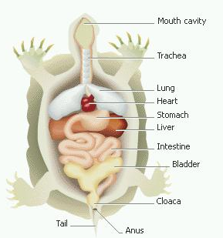
DIGESTIVE Just like in a frog, food moves from PHARYNX (back of throat) down the GULLET into the ESOPHAGUS to the STOMACH. Acid secreted by the walls of the stomach and the stomach muscles work to break down food. The PYLORIC SPHINCTER muscle at the end of the stomach controls the passing of digested food into the SMALL INTESTINE. The upper portion of the SMALL INTESTINE closest to the stomach is the DUODENUM. The next coiled section is the ILEUM. A fan-like membrane called the MESENTERY holds the folds of the small intestine together. The SMALL INTESTINE receives bile from the LIVER and pancreatic enzymes (including trypsin) from the PANCREAS. Digestion is completed here and nutrients are absorbed through the VILLI (small fingerlike extensions) lining the small intestine. The lower end of the small intestine leads into the LARGE INTESTINE (also called the COLON),where undigested waste is collected and passed into the CLOACA, a multipurpose cavity. Digestive waste, nitrogen waste from the kidneys (urine), as well as eggs and sperm all pass through the CLOACA on their way out of the body through the VENT. The main functions of the lobed LIVER are to MAKE BILE, STORE GLYCOGEN and VITAMINS, and PROCESS TOXINS including NITROGEN WASTE for the kidneys to remove.

THE GALL BLADDER, a greenish colored sac found in the liver, stores BILE made by the LIVER. The PANCREAS is an elongated organ located in the first loop of intestine between the beginning of the small intestine and stomach. It secretes TRYPSIN that is used in the small intestine to break down proteins.

ENDOCRINE
Hormones secreted by the THYROID gland control heart rate, growth, nutrient utilization, and reproduction. The PANCREAS makes INSULIN which causes cells to take up glucose from the blood and store it as glycogen and GLUCAGON which causes cells to release stored glucose into the bloodstream.

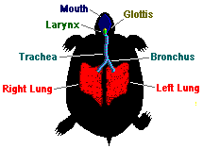
RESPIRATION:
Turtles use LUNGS for respiration. Air enters the GLOTTIS, moves down the TRACHEA (a tube lined with cartilage rings which help to hold the airway open) which splits
into two BRONCHI that carry air into the lungs. Unlike a frog whose lungs were simple sacs, the lungs in a turtle have many small individual air sacs called
ALVEOLI (sing. ALVEOLUS) to increase surface area
for greater gas exchange. Some sea turtles can exchange
gases through the skin of their cloaca.
CIRCULATORY SYSTEM
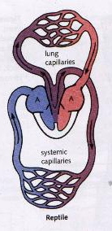
Like amphibians, the circulatory system in reptiles consists of a CLOSED TWO LOOP SYSTEM and a THREE CHAMBER HEART surrounded by a PERICARDIAL MEMBRANE. Locate the RIGHT ATRIUM, LEFT ATRIUM, and VENTRICLE. The SINUS VENOSUS and CONUS ARTERIOSUS ARE SMALLER THAN IN AMPHIBIANS. In fact the SINUS VENOSUS is even absent in some species. The CONUS ARTERIOSUS forms the base of the 3 large arteries leaving the heart.

The PULMONARY CIRCULATION carries deoxygenated blood from the heart to the lungs, then returns oxygenated blood to the heart. The SYSTEMIC CIRCULATION carries oxygenated blood from the heart to the muscles and body organs and brings deoxygenated blood back to the heart. Blood going to the kidneys (RENAL circulation), to the liver (HEPATIC circulation), and blood that supplies the heart itself (CORONARY circulation) are special parts of the SYSTEMIC loop. Remember adding a second loop has the advantages of FASTER BLOOD FLOW to the body organs and MORE EFFICIENT delivery of oxygen.

Low oxygen blood returning from the body enters the SINUS VENOSUS. From there it enters the RIGHT ATRIUM. At the same time high oxygen blood returning from the lungs enters the LEFT ATRIUM. When the atria contract both kinds of blood are sent to the VENTRICLE. The turtle heart is different from that seen in frogs. In most reptiles a PARTIAL SEPTUM appears to separate the ventricle to further prevent mixing to the HIGH and LOW oxygen blood that shares this pumping chamber. (In Crocodilians this septum divider is complete making crocodilians the only reptiles with a 4 chamber heart.) When the ventricle contracts, both kinds of blood pass through the CONUS ARTERIOSUS, which has a valve to prevent mixing of high and low oxygen blood. Large arteries then carry the high oxygen blood out to the body organs and muscles and low oxygen blood is sent to the lungs to pick up oxygen.
The reptile circulatory system has a flexibility that amphibians, birds, and mammals do not. Pumping blood through the lungs requires energy. Under some circumstances it is advantageous for a reptile to divert blood away from the lungs to conserve energy.

There are times when a reptile may want to save energy by bypassing the lungs
1. when it is inactive (may go a long time without breathing)
2. when holding breath underwater
3. when they want to warm up fast

By constricting the blood flow to the pulmonary arteries, a reptile can redirect blood to the body and bypass (SKIP) the lungs to save energy. Bypassing the lungs can also help a reptile raise its body temperature quickly because warm blood from the skin can be directed to the organs deep inside.
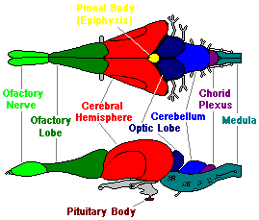
NERVOUS
Turtles are vertebrates with a DORSAL SPINAL CORD surrounded by bone which is actually fused to become part of the carapace shell. The brain of a reptile is about the same size as that of an amphibian of the same size and includes the same parts you have seen previously: medulla oblongata, cerebellum, optic lobes, cerebrum, and olfactory lobes. However, the CEREBRUM is much larger. Turtles have highly developed senses of SMELL and SIGHT, but they don’t hear well.

EXCRETORY
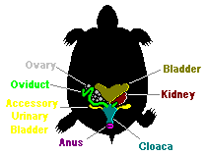
The excretory system of reptiles helps them to conserve body water. Snakes, lizards, and other land dwelling reptiles excrete nitrogen waste in the form of URIC ACID. Uric acid is must less toxic (poisonous) than ammonia or urea, so it requires little water for dilution. Reptiles lose only small amounts of water in their urine. The KIDNEYS, which lie on either side of the spine against the dorsal body wall, are the primary excretory organs. The kidneys filter NITROGEN WASTES (URIC ACID) from the blood, and dilute it with water to make URINE. Urine flows from the kidneys through urinary ducts to the CLOACA. The URINARY BLADDER stores urine until it is released through the VENT. The kidneys also REGULATE THE ION/WATER BALANCE in the blood and tissues.
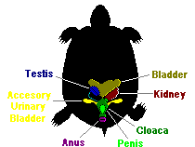

REPRODUCTION
A female turtle has paired OVARIES that produce the eggs, which pass through the OVIDUCTS, and passed out via the CLOACA through the VENT. Males have TESTES that make the sperm which passes through tubules called VAS DEFERENS to the CLOACA and out of the body. Fertilization in turtles is INTERNAL. Males have a PENIS to deposit the sperm inside the female’s body which increases the chances of fertilization. The reproductive pattern seen in turtles and tortoises is OVIPARITY. The female’s reproductive tract encloses each egg in a tough protective shell as it passes through the OVIDUCTS.
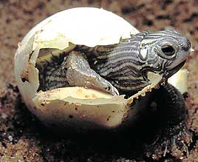
The female scoops out a hole with her hind legs, deposits the eggs, and covers the nest. Most species of reptiles provide no care for their eggs or young. Marine turtles often migrate long distances to lay their eggs on the same beach where they hatched. Reptiles, including turtles, have DIRECT DEVELOPMENT. Baby turtles hatch from their eggs looking like miniature adults.

SEX DETERMINATION
In most organisms, an individual’s sex is determined by the presence of X or Y chromosomes. In humans XX makes you a female, Xy makes you a male. In many reptiles, sex is determined by the temperature at which the egg is incubated. Location OF the nest (shady or in the sun) and location IN the nest (bottom or top) determines whether the baby turtle will be a boy or girl. Some studies suggest that female reptiles may put their nests in different places depending on the male:female ratio in the population.

Three kinds of SEXUAL REPRODUCTION in vertebrates can be distinguished groups based on the location of embryo development and where nourishment for the developing embryo comes from.
OVIPARITY- embryo is enclosed in a shell and develops outside the
mother’s body; nourishment comes from the egg
OVOVIVIPARITY-embryo is enclosed in a shell but is held inside the
mother’s body and laid just before hatching or hatches inside the
mother; nourishment comes from the egg
VIVIPARITY-embryo grows inside the mother’s body; nourishment comes
from the mother through a placenta

Reptiles (mainly snakes) are the only vertebrate group that displays all of these kinds. Most reptiles, including turtles and tortoises are OVIPAROUS.

AMNIOTIC EGGS (4 membranes and a shell)
Turtles lay AMNIOTIC EGGS with 4 specialized membranes, which surround the embryo in a self-contained aquatic environment. The tough shell on the outside provides more protection to the embryo inside than the jelly coating of an amphibian egg. The AMNIOTIC EGG is an advancement that allowed reptiles to move out onto land and not have to return to water to lay their eggs.
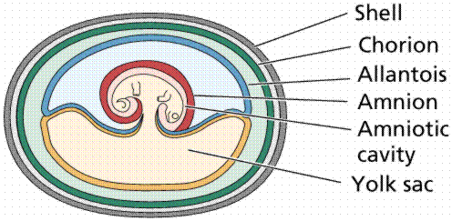

The diagram above shows the internal structure of such an egg. The egg is named for the AMNION the thin membrane that encloses the developing embryo and the fluid that surrounds it; The YOLK SAC encloses the yolk, a fat-rich food source for the growing embryo; The ALLANTOIS stores nitrogen waste produced by the growing embryo AND exchanges gases with the environment; The CHORION surrounds all the other membranes and helps protect the developing embryo. Protein and water needed by the embryo are contained in the ALBUMEN.

The amniotic egg first evolved in reptiles but also occurs in birds and a few mammals (like the platypus). Scientists believe this is evidence that reptiles, birds, and mammals evolved from a common ancestor.

PIGEON DISSECTION
PHYLUM: Chordata
SUBPHYLUM: VERTEBRATA “bone covering nerve cord”
CLASS: Aves “bird”
ORDER: COLUMBIFORMES (pigeons & doves)

INTEGUMENTARY/BODY-

Modification for flight: FEATHERS provide lift; streamlined for decreased air resistance; insulation against heat loss; SKIN thin so weighs less

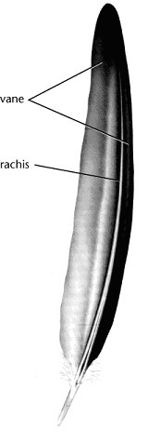
Birds are the only animals with FEATHERS. Feathers are modified scales made of KERATIN. Their function is to PROVIDE LIFT in flying and PRESERVE BODY HEAT. Feathers also provide coloration to attract a mate and hide from predators.
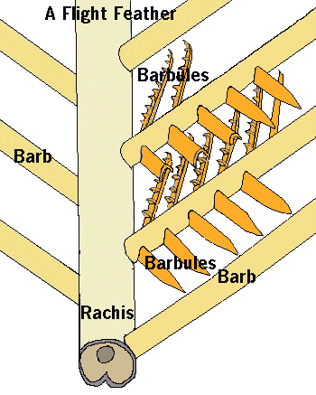
Examine your feather carefully: The structure of a feather combines MAXIMUM STRENGTH with MINIMUM WEIGHT. Feathers grow from tiny pits in the skin called FOLLICLES. Two VANES develop on opposite sides of a center shaft called the RACHIS. Each vane has many branches called BARBS. The barbs are zipped together “like Velcro” by microscopic hooks called BARBULES.

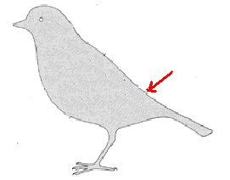
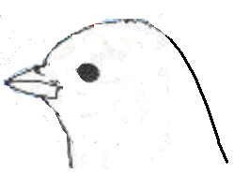
Birds straighten and care for their feathers by rubbing them with oil secreted by a PREEN GLAND at the base of their tail. Birds periodically MOLT or shed their feathers and grow new ones. Birds living in temperate climates usually replace their flight feathers (called a MAJOR MOLT) during late summer.

The fleshy bit of skin that lies over the beak is called the CERE. Find the NICTITATING MEMBRANE, the EAR OPENING, the BEAK, and EXTERNAL NARES.

Birds see in COLOR and have keen vision which is important in taking off, landing, spotting landmarks, hunting, and feeding. Having eyes on the sides of its head gives a bird a WIDE RANGE OF VISION This arrangement is most often seen in birds which may be prey of other animals so they can watch for predators more easily.

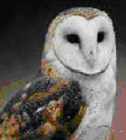
Birds with both eyes on the front of their head
have better BINOCULAR vision (DEPTH PERCEPTION) a necessity for hunting. This arrangement is most often seen in birds that are predators such as owls, hawks, and falcons.

Hearing is important to songbirds and in nocturnal birds
that must hunt for prey in the dark. Birds lack external
ears and have their TYMPANIC MEMBRANE inside.

NERVOUS
Modification for flight:
Large BRAIN for body size = “smarter”
Bigger CEREBRUM allows more complex behavior
(problem solving; learning; navigation; nesting; nest building; caring for young)
Bigger CEREBELLUM for muscle coordination during flight
Bigger OPTIC LOBES for better vision; color vision
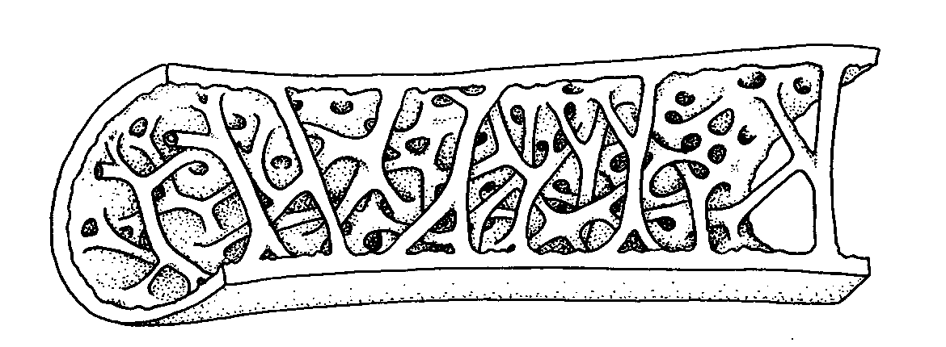
Concentration of IRON in brain of migrating birds to detect magnetic fields
(acts like a compass)

SKELETAL
Modification for flight:
Bones = thin & HOLLOW; Many bones are FUSED for strength;
AIR SACS from lungs extend into some bones making them less dense
PYGOSTYLE (fused lower vertebrae) support tail for lift & braking during flight;
FURCULA (fused collarbones) stabilize shoulders during flight;
STERNUM (large breastbone) to attach flight muscles
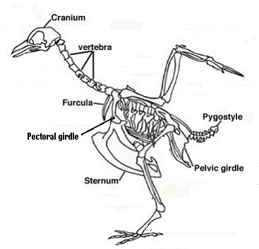

Bird bones are hollow to make them less dense than bones of non-flying animals.
Some bones (FURCULA, PYGOSYTLE) are fused to make them stronger.

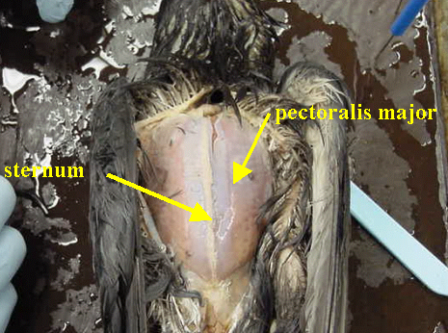
MUSCULAR
Modification for flight:
Large PECTORAL muscles attach to
sternum and power wings.
A bird’s pectoral muscle can make up over a
third of its body mass.

DIGESTIVE
Modification for flight:
2 part stomach to speed food through system;
Crop for storage allows birds to eat when stomach is full so food is always moving
through digestive system;
Food fuels high metabolism (ENDOTHERMIC) for energy for extended activity such as flying
Excess food stored as FAT for energy during long flights (migration)
Long SMALL INTESTINE to absorb lots of nutrients
Short LARGE INTESTINE to get rid of digestive waste faster
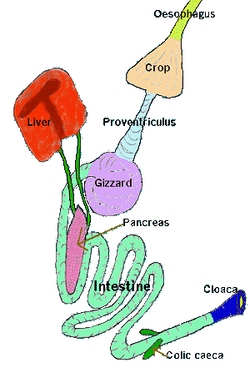
The large amount of energy needed to fly and regulate body heat (ENDOTHERMIC) is obtained by a quick and efficient digestive system.

Birds have NO TEETH to chew their food before it passes down the ESOPHAGUS into the CROP which stores food waiting to be digested. Birds have a TWO PART STOMACH to speed digestion. In the first chamber, the PROVENTRICULUS, acid and digestive enzymes begin breaking down the food. The second muscular portion called the GIZZARD contains small rocks the bird has swallowed which help in GRINDING the food.

Food is then passed into the very long SMALL INTESTINE where digestion is completed and nutrients are absorbed. The short LARGE INTESTINE absorbs water from and concentrates digestive waste.

The COLIC CAECA are found at the junction of the small and large intestine. These small pouches contain bacteria that AID IN DIGESTING PLANTS. Digestive waste is mixed with urine containing URIC ACID in the CLOACA before exiting through the VENT. The LIVER and PANCREAS still provide digestive enzymes

ENDOCRINE
Modification for flight:
THYROID maintains HIGH METABOLISM (burns glucose) to provide energy for flight
PANCREAS (makes INSULIN & GLUCAGON) regulates blood sugar levels so fuel is available
to power flight muscles
ENDOTHERMIC metabolism provides energy for extended activity (flight)

CIRCULATORY
Modification for flight:
Heart large for size of body
4 chamber heart (SEPTUM totally separates ventricle into 2)= most efficient/faster
2 loop system faster/gives extra push to blood going to body
RAPID HEART RATE moves oxygen/nutrients to body faster
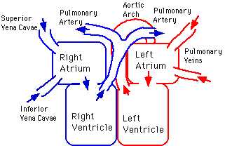
Birds have a CLOSED CIRCULATORY SYSTEM with 2 LOOPS (Pulmonary and Systemic) just like amphibians & reptiles. The difference in birds is the COMPLETE SEPARATION of the ventricle by a SEPTUM into a 4 CHAMBER HEART (2 atria and 2 ventricles). The SINUS VENOSUS and CONUS ARTERIOSUS have disappeared.
The LARGEST VEIN returning to the heart is the VENA CAVA. The largest arteries carrying blood away from the heart are the PULMONARY (to LUNGS) and the AORTA (to BODY).

Compared to reptiles and most other vertebrates, birds have a RAPID HEARTBEAT. Like amphibians and reptiles the SPLEEN still makes, stores, and recycles red blood cells. Like reptiles and amphibians, bird red blood cells HAVE NUCLEI. Human RBC’s don’t.
RESPIRATORY
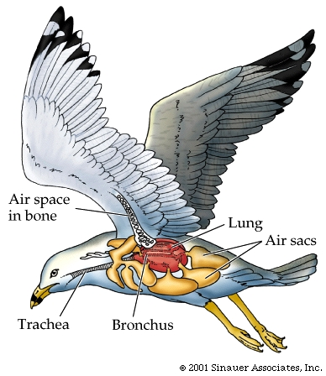
Modification for flight:
SUPER EFFICIENT respiratory system to meet HIGH OXYGEN DEMAND
AIR SACS allow oxygenated air in lungs during both INHALE and EXHALE
to provide more oxygen during high activity (flight)
AIR SACS from lungs extend into bones to decrease density
ALVEOLI in lungs increase surface area for more gas exchange

Birds have the MOST EFFICIENT respiratory system of any terrestrial vertebrate. Rapid metabolism requires an abundant supply of oxygen. Yet some birds migrate thousands of miles at high altitudes (up to 23,000 ft) where oxygen levels are very low. Air enters through EXTERNAL NARES at the base of the beak and moves into the TRACHEA through the GLOTTIS opening in the back of the mouth cavity.

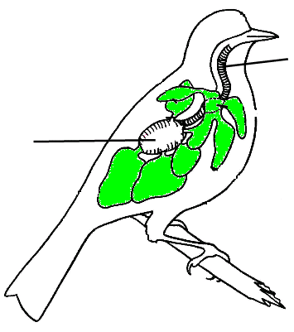
The air moves down the TRACHEA and branches into two BRONCHI (sing. BRONCHUS). From there SOME OF THE AIR ENTERS THE LUNGS. However, about 75% of the air bypasses the lungs and flows directly into the POSTERIOR AIR SACS that extend from the lungs and occupy a large portion of the bird’s chest and abdominal cavity (COELOM). These sacs also extend into some of the LONG BONES, also REDUCE THE DENSITY of the bird.

GAS EXCHANGE DOES NOT OCCUR IN THE AIR SACS. Their function is to STORE AIR. When the bird exhales the LOW OXYGEN AIR from its lungs moves into the ANTERIOR AIR SACS and the HIGH OXYGEN AIR from the posterior air sacs moves into the lungs. This way, the bird has high oxygen air in its lungs at all times . . . both on the INHALE and on the EXHALE! ALVEOLI in the lungs increase surface area for greater gas exchange.

The SYRINX (voice box), which produces sound, is a diamond shaped organ located where the trachea splits into the 2 bronchi. By regulating the flow of air birds can produce songs of great range and complexity. Male birds sing to warn away other males and to attract females.

EXCRETORY
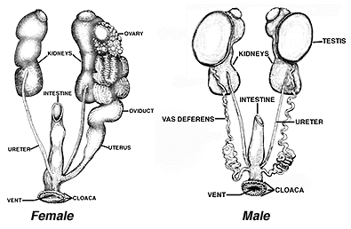
Modification for flight:
No Urinary bladder = less weight
Nitrogen waste eliminated as URIC ACID (needs the least water to dilute);
Waste eliminated as made/ No urine storage

The avian excretory system is lightweight and efficient. The excretory organs in birds are the KIDNEYS. These elongated brownish organs are located along the back body wall under the reproductive organs on either side of the spinal cord. The kidneys REGULATE ION/WATER BALANCE of blood and tissues and REMOVE NITROGEN WASTE. Unlike other vertebrates, birds DO NOT STORE URINE… there is NO URINARY BLADDER! The kidneys filter nitrogen waste from the blood in the form of URIC ACID. This form is the LEAST TOXIC and REQUIRES THE LEAST AMOUNT OF WATER TO DILUTE. Concentrated uric acid waste moves through ducts called URETERS to the CLOACA, where it mixes with digestive waste and is eliminated through the VENT. Bird droppings are a mixture of feces and uric acid (the white colored material you see in “bird poop”).

REPRODUCTIVE
Modification for flight:
Females have OVARY and OVIDUCT on only 1 side (less weight)
Ovary enlarges during breeding season; shrinks in size rest of year
OVIPARITY = Lay eggs outside (less weight if egg NOT kept in body)

In males sperm is produced in the TESTES near the kidneys. Sperm passes through a small tube called VAS DEFERENS (plural: VASA DEFERENTIA) into the CLOACA.
During mating the male presses his cloaca against the female’s cloaca and releases sperm. Most females have a SINGLE OVARY ON THE LEFT SIDE of the body.
Remember seeing all the eggs in fish, frogs, and turtles… eggs are heavy! Having a single ovary lightens the load for flying! Birds lay AMNIOTIC EGGS. The OVARY produces the eggs and the albumen and shell are added in the OVIDUCT, just like in a turtle. Eggs pass through the CLOACA and VENT and are laid outside the body. CALCIUM CARBONATE makes the shell hard so birds can sit on the eggs to keep them warm.
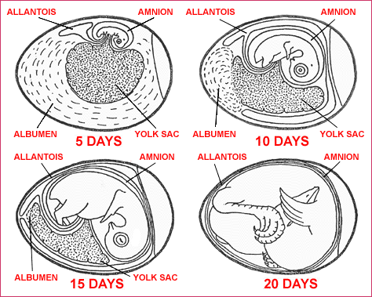
Most birds lay eggs in nests. Nests hold eggs, conceal young birds from predators, provide shelter from the weather, and sometimes attract a mate. One or both parents incubate,
(WARM) the eggs by sitting on them. A thickened, featherless patch of skin on the abdomen called a BROOD PATCH, allows skin to egg contact for more warmth.

In birds in the ORDER Columbiformes (pigeons & doves) the crop in both males and females secretes a nutritious milk-like fluid called CROP MILK to feed the young.

Birds that lay eggs in nests on or near the ground where they are more vulnerable to predators have PRECOCIAL YOUNG (babies that can walk, swim, and feed themselves shortly after birth). This allows the baby birds to be mobile sooner and increases chances for survival by better escaping predators. Birds that lay eggs in nests higher up in trees or places where predators can’t reach as easily have ALTRICIAL YOUNG (babies that are featherless, blind, and helpless which must be fed and cared for by the parents). This kind of baby would quickly be eaten if it was laid in a nest on the ground! Hatching this kind of babies up high protects them until they are more mature.

RAT DISSECTION
PHYLUM: Chordata
SUBPHYLUM: VERTEBRATA “bone covering nerve cord”
CLASS: MAMMALIA “breast”
ORDER: RODENTIA “to gnaw”
There are about 4,440 species in the CLASS MAMMALIA. Mammals are VERTEBRATE DEUTEROSTOMES and live on every continent and in every ocean. 95% of all mammals (including the rat) are placental mammals. The developing embryos grow inside the mother attached to a PLACENTA which provides oxygen and nutrients to the young, which are born alive.

ENDOTHERMIC:
Mammals, like birds, are ENDOTHERMS. They generate heat internally by breaking down food and burning it for energy. An ENDOTHERM can LIVE IN COLD CLIMATES and BE ACTIVE FOR EXTENDED PERIODS OF TIME. Because of its faster metabolism a mammal NEEDS MORE FOOD than the same size reptile.
INTEGUMENTARY:
One of the characteristics of mammals is fur or hair.
Heat is constantly escaping from a mammal’s body through its skin and exhaled air. Because producing heat requires so much energy, mammals limit their loss of body heat to the environment with insulating layers of HAIR/FUR and layers of FAT. Hair/fur is made from KERATIN (the same PROTEIN that makes reptile scales, bird feathers, and your hair & fingernails). Fur also provides CAMOUFLAGE for protection.

Unlike reptiles, the limbs of mammals DO NOT protrude at right angles to their bodies. The TAIL is used for balance and support when sitting up to use the front paws. Mammals have CLAWS, hooves, or fingernails.

Mammals show CEPHALIZATION (the concentration of their sense organs in the anterior end). Locate the forward facing eyes (for depth perception). Notice there is NO NICTITATING MEMBRANE
over the eye as in amphibians, reptiles, and birds.
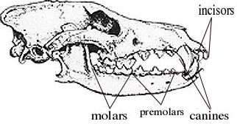
Another characteristic of mammals is SPECIALIZED TEETH. All animals have teeth that correspond to the type of food they eat. The name RODENTIA comes from the Latin word meaning “to gnaw”. Rodents such as the rat have 2 pairs of CONTINUOUSLY GROWING INCISORS (front teeth) which are kept at the correct length by constant chewing.
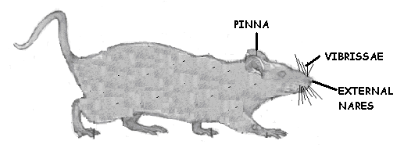
VIBRISSAE (whiskers) are sensory organs which enable rats to feel their way through tight spaces in the dark. The external ear opening is surrounded by a PINNA (a flap of cartilage covered by skin) that can be rotated to direct sound into the ear. The TYMPANIC MEMBRANE is located inside the head and 3 bones (instead of one) now conduct sound waves from eardrum to inner ear. The EXTERNAL NARES (nostrils) are located near the tip of the snout and are used for respiration and odor detection.
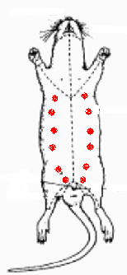
Another one of the characteristics of mammals is that
they MAKE MILK to feed their young. Locate the NIPPLES
on the ventral side of your rat. These connect to MAMMARY GLANDS (modified sweat glands) inside which produce milk. Males also have nipples, but because they lack the necessary female hormones, their mammary glands do not produce milk.

Locate the exit openings for the digestive, excretory, and reproductive body systems. Like humans, male rats have 2 exit openings; females have 3 exit openings.Egg layers like reptiles and birds have a cloaca and a vent.

PLACENTAL MAMMALS (mammals that don’t lay eggs) have a RECTUM and an ANUS instead of a cloaca and vent. The digestive system has its own unshared exit opening (ANUS).
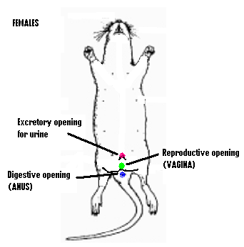
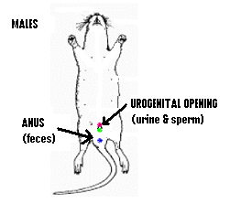

MALES have TWO OPENINGS FEMALES have THREE OPENINGS
SHARED UROGENITAL OPENING separate openings for digestive (ANUS)
which releases both SPERM and URINE. reproductive, and excretory systems
and ANUS (digestive)

WHAT SEX IS IT?
The ideal temperature necessary for sperm production is actually a few degrees cooler than body temperature. So males have their TESTES suspended outside their bodies in a sac (SCROTUM) to keep them cooler. Testes outside the body in a scrotum are called TESTICLES. Mammals are EUCOELOMATES. The space you see surrounding the internal organs is “true coelom” (body cavity lined on both sides by mesoderm). The DIAPHRAGM is a sheet of muscle which separates the body cavity into two compartments: THORACIC CAVITY (containing heart and lungs) and ABDOMINAL CAVITY (containing digestive, excretory, and reproductive organs). This muscle contracts to PULL AIR INTO the lungs (NEGATIVE PRESSURE BREATHING) and improve breathing efficiency. The MESENTERY membrane still surrounds and supports the digestive system. The yellowish structures are stored FAT which can be used for energy.
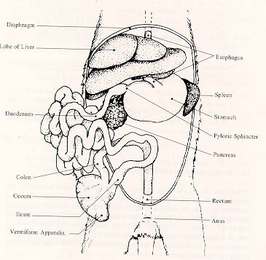
DIGESTIVE In all of the animals seen thus far, digestion of food has begun in the stomach. Mammals start digesting their food in the MOUTH. SPECIALIZED TEETH cut, grind, and shred the food and SALIVARY GLANDS produce digestive enzymes (AMYLASE) which breaks down starch into sugars and begin to chemically digest the food before it reaches the stomach.
Food moves from PHARYNX (back of throat) into the GULLET opening and down the ESOPHAGUS to the STOMACH. Stomach ACID secreted by the walls of the stomach and the stomach muscles work to break down food. The PYLORIC SPHINCTER, a circular muscle, controls the passing of digested food into the SMALL INTESTINE.
Mammals now have 3 sections of small intestine: upper portion of the SMALL INTESTINE closest to the stomach, (DUODENUM), middle portion (JEJUNUM), and final section (ILEUM). The SMALL INTESTINE receives bile from the LIVER and pancreatic enzymes (including trypsin) from the PANCREAS. DIGESTION IS COMPLETED HERE and NUTRIENTS ARE ABSORBED through the VILLI (small fingerlike extensions) lining the small intestine. A fan-like membrane called the MESENTERY holds the folds of the small intestine together.

At the junction of the small and large intestine is a large pouch (CECUM). Remember: vertebrates (including mammals) DO NOT produce the digestive enzymes needed to digest cellulose in plants. The CECUM pouch contains microorganisms that can break down plants. Humans have an APPENDIX, a vestigial (leftover non-functioning) cecum. The lower end of the small intestine leads into the LARGE INTESTINE (COLON), where undigested waste is collected and passed into the RECTUM before exiting through the ANUS. The excretory and reproductive systems in female mammals use different exit openings. Marsupial and monotreme mammals still have a cloaca.
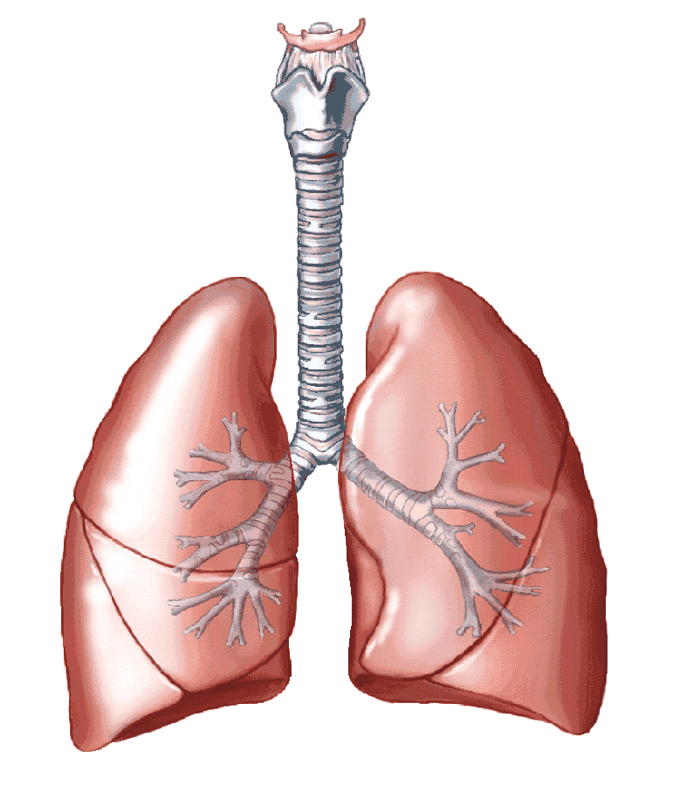
The main functions of the lobed LIVER are to MAKE BILE, STORE GLYCOGEN and VITAMINS, and PROCESS NITROGEN WASTE and other TOXINS (poisons) for the kidneys to remove. BILE made by the liver is stored in a GALL BLADDER in most mammals. However, rats DO NOT HAVE A GALL BLADDER ! Bile is made as needed and released directly into the DUODENUM. The PANCREAS is an elongated organ located in the first loop of intestine between the beginning of the small intestine and stomach. It secretes PANCREATIC ENZYMES (including trypsin used in the small intestine to break down proteins), and INSULIN and GLUCAGON (to regulate blood glucose levels).

RESPIRATION:
The GLOTTIS, in the back of the throat is the opening to the respiratory system. The EPIGLOTTIS (a movable flap of tissue) covers the opening to the respiratory system and keeps food from “going down the wrong tube” when swallowing. The TRACHEA, containing cartilage rings to keep the airway open, splits into 2 BRONCHI. The respiratory organ in mammals is the lungs, which have many small individual air sacs called ALVEOLI (sing.ALVEOLUS) to increase surface area for greater gas exchange. The DIAPHRAGM (a sheet of muscle below the ribcage contracts to pull air into the lungs. A voice box is located in the trachea and makes sound as air passes through.

ENDOCRINE:
The endocrine system in mammals is the most complex. The THYROID GLAND regulates heart rate and metabolism, but many other ENDOCRINE GLANDS such as the PITUITARY, ADRENAL, and PARATHYROID GLANDS also help to control other body organs, growth, development, and function.

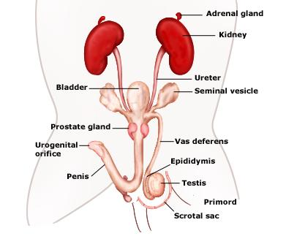
EXCRETORY
Mammals excrete nitrogen waste in the form of UREA, which is toxic and must be diluted with water. The KIDNEYS, which lie on either side of the spine against the dorsal body wall, are the primary excretory organs. The kidneys filter NITROGEN WASTES (UREA) from the blood, and dilute it with water to make URINE. Urine flows from the kidneys through URETERS to the URINARY BLADDER for storage. Urine travels in the URETHRA from the bladder to the exit. In addition to removing nitrogen waste, the kidneys also REGULATE THE ION/WATER BALANCE in the blood and tissues (OSMOREGULATION).

CIRCULATORY
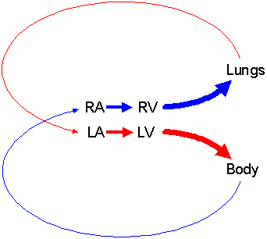
Like birds, mammals have a CLOSED CIRCULATORY SYSTEM with 2 LOOPS and a FOUR CHAMBER HEART surrounded by a PERICARDIAL MEMBRANE. Locate the RIGHT ATRIUM, LEFT ATRIUM, LEFT VENTRICLE, and RIGHT VENTRICLE. The SINUS VENOSUS or CONUS ARTERIOSUS have disappeared.

The PULMONARY ARTERIES carry LOW OXYGEN blood to the from the heart to the lungs and the PULMONARY VEINS return blood return HIGH OXYGEN blood to the heart.
The SYSTEMIC CIRCULATION carries oxygenated blood from the heart to the muscles and body organs and brings deoxygenated blood back to the heart, just like amphibians & reptiles. (RENAL-to kidneys; CORONARY-to heart; HEPATIC-to liver). Remember adding a second loop has the advantages of faster blood flow to the body organs and more efficient delivery of oxygen.

ARTERIES carry blood away from heart; VEINS return blood to heart; CAPILLARIES carry out gas/nutrient/waste exchange. The SINUS VENOSUS and CONUS ARTERIOSUS have disappeared. Largest vein returning to heart from body = VENA CAVA; Largest artery leaving heart to body organs = AORTA.

Low oxygen blood returning from the body enters the Right Atrium. At the same time high oxygen blood returning from the lungs enters the LEFT ATRIUM. When the atria contract, blood is sent to the corresponding VENTRICLE. The right side of the heart only carries low oxygen blood. The left side only carries high oxygen blood.

The LEFT VENTRICLE is thicker and stronger than the RIGHT ventricle because the left side has to pump blood a farther distance out to all the body parts. The right ventricle just has to send blood to the lungs, which are close by.

The SPLEEN still makes, stores, and processes blood cells. Unlike other vertebrates with red blood cells the RED BLOOD CELLS in mammals have lost THEIR NUCLEI to allow more room for oxygen transport.

REPRODUCTION
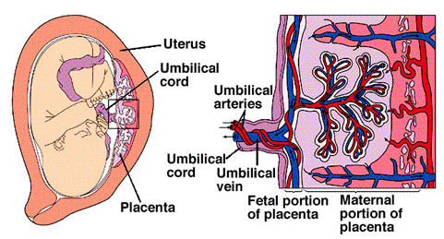

Rats are PLACENTAL MAMMALS. Males have TESTES that make the sperm. The sperm mature and grow their tails as they pass through the EPIDIDYMIS (coiled tubules on top of the testes). The SEMINAL VESICLES add fluids to sperm. Mature sperm passes through tubules called VAS DEFERENS to the URETHRA and leaves the body through the PENIS. Males have a PENIS to deposit the sperm inside the female’s body, which increases the chances of fertilization.

A female rat has paired OVARIES that produce the eggs, which are carried to the UTERUS in FALLOPIAN TUBES (OVIDUCTS). Fertilization is INTERNAL and occurs in the Fallopian tubes. If fertilization occurs, the developing embryo grows inside the mother’s UTERUS, nourished by a PLACENTA. Oxygen and nutrients diffuse from mother to baby AND nitrogen waste and carbon dioxide diffuse from baby to mother across the close placenta connection. Young are born alive and pass out of the body through the VAGINA.

The reproductive pattern seen in rats (and most other mammals) is VIVIPARITY and most offspring are born looking like smaller versions of the adult (DIRECT DEVELOPMENT). After birth MAMMARY GLANDS in the female produce milk to feed their young.

